BEING ASSERTIVE
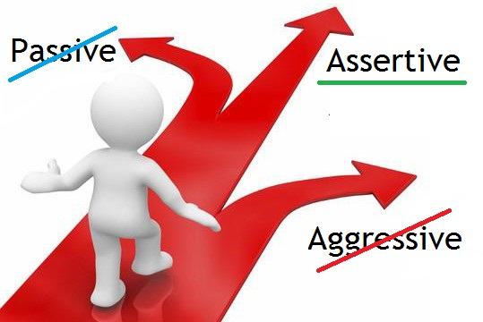
Today, we talked about the importance of self-advocating when necessary. It’s important to be able to stand up for yourself, but also, it can be a delicate situation.

If I want to be strong, but I also want to be polite… how do I do it?

There is certain language we use in English to achieve this goal. Everyone knows what you are saying with these expressions, but they allow all people in the conversation to feel more respected and comfortable. You can find a compromise between being passive and being aggressive.

“Assertive” (adj): being confident in standing up for yourself, but also calm.

- Take a look at this website to see some tips and language examples:
https://www.londonschool.com/blog/5-tips-polite-and-diplomatic-language/

- Review the “Alternative conversation” from class. Which responses are aggressive (1), passive (1), and assertive (2)? Highlight them.

Dave: “I have a problem with my fridge door. Would you like to see and then fix it, please?”
PM: What is the problem?
Dave: My fridge is leaking.
PM: Have you tried changing the temperature?
Dave: Yes, I have changed it. It doesn’t help.
PM: Okay, well try changing it again. Come back tomorrow if it is still leaking.
- Dave: I’m sorry, but I don’t think that’s necessary. I know changing the temperature doesn’t help.
- Dave: I just told you that doesn’t help. I want to fill out a request now.
- Dave: I can change it again, but I still want to fill out a maintenance request now, please.
- Dave: Okay, I will try that. Thank you.

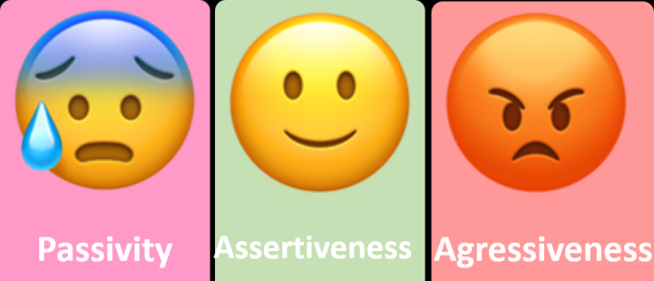

- Create your own multiple choice. Explain which answer is assertive, which is aggressive, and which is passive. Then, explain which one you would use in your real life and why.

(Reminder: You don’t have to choose the assertive option! Choose whichever you feel most comfortable with personally).

“Hello. My window is missing a windowpane. It is very cold in my bathroom. Can you please come replace the windowpane?

PM:
Dave:

PM:

- Dave:
- Dave:
- Dave:
- Dave:

