WELCOME BACK! IT’S WEEK THREE – DAY 11

PRONUNCIATION WARM-UP
Review terms. Example: “Serena”
What is a “syllable”:
What is “word stress”:
How is a stressed syllable pronounced?

higher or lower longer or shorter quieter or louder

PRONUNCIATION

So, if we care most about the stressed syllable, what happens to the other ones?

Sometimes, a syllable disappears.
Main/te/nance com/for/ta/ble ve/ge/ta/ble
Bu/si/ness dif/fe/rent fa/mi/ly

Written: Spoken:
Main/te/nance Maint/nance
com/for/ta/ble comf/r/ble
Bu/si/ness Bus/ness
dif/fe/rent diff/rent
ve/ge/ta/ble veg/ta/ble
fa/mi/ly fam/ly
Often, vowels turn into an ‘uh’ sound, schwa /ə/ Resource: https://learnersdictionary.com/
a/no/ther be/lieve provide holiday
idea about probably polite

Which names in our class have a schwa sound?
Sa/ra Ri/sa Se/re/na Nid/ya Gua/da/lu/pe
Hil/da De/la

GRAMMAR: CONDITIONALS (If… then…)
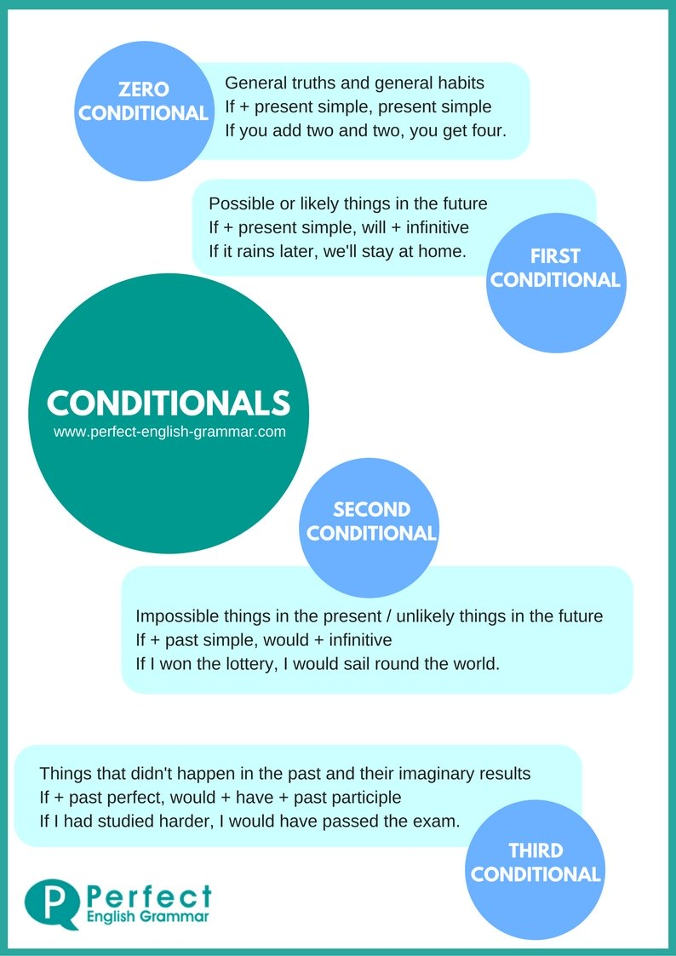
Zero conditional: used for general truths and habits.
If/When I (present), I (present). e.g. If I sleep for six hours, I am tired the next day.
If I cook, they clean.
- If my husband cooks (cook), he… destroys my kitchen, he learns more, he always cleans the kitchen
- If kids eat (eat) a lot of sugar, they… are sick the next day, they become fat.
- When I go (go) to bed at 8 p.m., I… wake up early.
- If you clean (clean) the house, your mom loves you more, you have less time to sleep.

Also, create 3 sentences that are always true for you.
Sara’s:
- If I sleep for six hours, I am tired the next day.
- If I don’t exercise, I have too much energy.
- When I watch the Office, I laugh.

First conditional: used for possible things in the future.
If I (present), I (future). e.g. If my friend is free, we will probably go hiking.

- If I go (go) out tonight, I’ll go (go) to the movies.
- If I don’t see (not/see) you Tuesday, I will see (see) you Wednesday.
- If it is (be) sunny, we will have (have) a picnic in the park.
- If you go (go) to the store and buy groceries, she will cook (cook) dinner.
- If you eat my chocolate… you will have a big problem, I’ll be angry.
- If you wake your dad up… you’ll have to run away, he won’t care.
- If my friend invites me to a party… I will enjoy it, I will be happy.
- If I win $1,000… I will go around the world, I will save the money.

TRAFFIC SIGNS
Quiz. https://forms.gle/NF6jUJ9n9awHThbe9

If you want or need specific driving vocabulary, take a look at: https://www.excellentesl4u.com/esl-driving-vocabulary.html

