CLASS, IT’S DAY 12!

WARM-UP
Zero and 1st conditionals. -possible -habits -future
Zero conditionals tell us general truths and habits.
For example, 1. If we go to the store, we spend money.
2. When we go to the store, we spend money.
3.
1st conditionals tell us possible things in the future.
For example, 1. If it’s sunny, I’m going to go on a hike.
2. If it’s sunny, I will go on a hike.
3. If it’s sunny, I won’t go on a hike.

Types of signs. -warnings -rules -information
Red and white signs give rules. 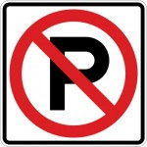 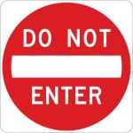
Yellow and orange signs give warnings. 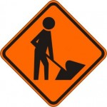 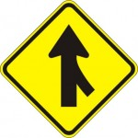
Blue, green, and brown signs give information. 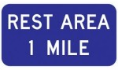 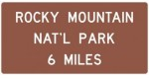

MAKING RULES FOR TRAFFIC SIGNS
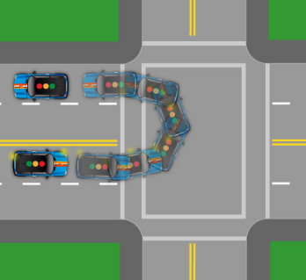

Some helpful vocabulary.
“to make a U-turn”
“to speed up/slow down”
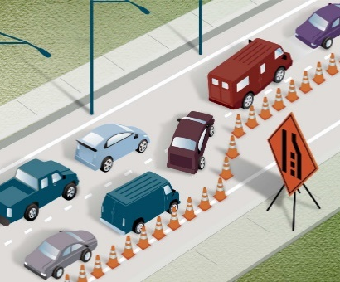
“to merge”
“to change lanes”

Make conditional sentences with the signs. (BR)

Rules: Zero conditional.
 | (stop)  When I see this sign, I stop. |  | (not enter)  If I see this sign, I don’t enter.
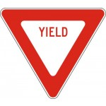 | (slow down)  When I see this sign, I slow down. |  | (not park)  When I see this sign, I don’t park here.
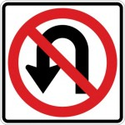 | (not make a U-turn) |  | (go one way)
Warnings: First conditional.
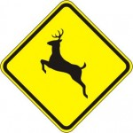 | (be careful)  If I see this sign, I’ll be more careful… I’ll watch for deer. |  | (slow down)  If I see this sign, I will slow down.
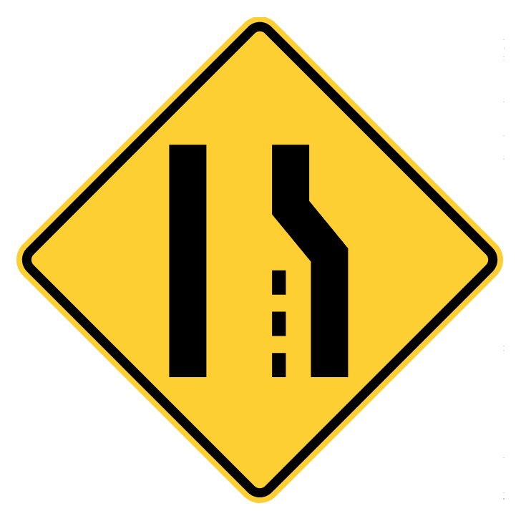 | (changes lanes) |  | (merge)
Information: First conditional.
 | (take a break) |  | (stop)

GIVING DIRECTIONS
Brainstorm direction phrases and prepositions.
Turn around It’s next to…
Stop in front of, opposite, behind, across from
Go left/right, turn left/right on top of
Yield At the bottom of the hill…
Go straight Once you pass ___, take a left…

Add more from paragraph.
Okay, take a left out of the parking lot and go toward Monroe Street. When you hit Monroe, take a right. Go over the bridge. Monroe turns into a one-way, so you have to go straight at the intersection. At Main Avenue, take a left. Go down Main for three blocks, and then take another left. Atticus will be on your right.
Nidya: Excuse me, how can I get to Atticus?
Risa: Okay, take a left out of the parking lot and go toward Monroe Street. When you hit Monroe, take a right. Go over the bridge. Monroe turns into a one-way, so you have to go straight at the intersection. At Main Avenue, take a left. Go down Main for three blocks, and then take another left. Atticus will be on your right.
Nidya: Okay, thanks so much!
Starting from: My Fresh Basket Going to: Atticus

Activity #1
Starting from: Main Market Co-op Going to: Rocket Bakery
-take a left -how to get to -go down -turn right -on your left

A: Hi, could you please tell me 1. __________ Rocket Bakery?
B: Sure! It’s really easy. Just 2. __________ Browne Street, 3. __________ on Sprague, and go for a while. You’ll pass the Davenport Hotel on your left. At Cedar Street, 4. __________. Rocket Bakery is just one block down Cedar, 5. __________.

Activity #2
Starting from: Lucky Leaf Co. Going to: Cotsco
Order the directions
- Take the Havana Street exit. - From here, go toward Monroe Street.
- Take the entrance for I-90 East and merge onto the highway.
- Drive for about ten minutes. - When you hit Sprague Avenue, take a right.
- At Monroe, take a right. - Drive for a few blocks, and Costco will be on your left.

- From here, go toward Monroe Street.

Answers:
- From here, go toward Monroe Street.
- At Monroe, take a right.
- Take the entrance for I-90 East and merge onto the highway.
- Drive for about ten minutes.
- Take the Havana Street exit.
- When you hit Sprague Avenue, take a right.
- Drive for a few blocks, and Costco will be on your left.

PRACTICE
In your pair, you will create your own directions between two locations.
You should:
- Choose a starting from and going to location
- Look at the directions on Google Maps
- Write your mini dialogue
  - A asks for help
  - B gives detailed directions
  - A says thanks
We will come back as a group and read them (if we have time).
You will turn it in to me, so write it in a way you can share with me (take a picture of your paper, WhatsApp your sentences, etc.).

Example:
Starting from: My Fresh Basket Going to: Atticus Coffee
A: Excuse me, how can I get to Atticus Coffee?
B: Okay, take a left out of the parking lot and go toward Monroe Street. When you hit Monroe, take a right. Go over the bridge. Monroe turns into a one-way, so you have to go straight at the intersection. At Main Avenue, take a left. Go down Main for three blocks, and then take another left. Atticus Coffee will be on your right.
A: Okay, thanks so much!

