YWELCOME TO WEDNESDAY, DAY 13!

WARM-UP

2ND CONDITIONAL
We use the 2nd conditional to talk about hypothetical situations.
e.g. “If I could play any instrument perfectly, I would play the guitar.”
e.g. “If I had more time, I would read more.”
e.g. “If I was/were on vacation right now, I… would walk around, hike, snorkel, go to he theatre…
Structure: If + (simple past verb), would/could + (infinitive/base form)

DIFFERENTIATING
Examples.
- If I eat octopus again, I’ll be unhappy. a. zero conditional
- If I eat octopus, I feel sick. b. 1st conditional
- If I ate octopus again, I would try a new recipe. c. 2nd conditional

- If I could travel, I would go see my friend in Indiana.
- If I travel, I enjoy myself.
- If I travel in August, I’ll go see my mom.

Uses.
- Used to express hypothetical situations.
- Used to express possible situations.
- Used to express daily situations and truths.

Structure: If + (simple past verb), would/could + (infinitive/base form)
COULD VS. WOULD
Could expresses possibility or ability. It doesn’t express desire or opinion. (can)
e.g. If I lived in a house, I could be noisier.
Would expresses possibility or intent. Also, it expresses desire and/or opinion.
e.g. If I lived in a house, I would be noisier.

Could vs. would.
Could | Would
If Marta were faster, she could be a great runner. | If Marta were faster, she would be a great runner.
- If Matt were smarter, he could be an engineer. | - If Matt were smarter, he would be an engineer.
If Emma had vacation time, she could visit Rebecca. – an option | If Emma had vacation time, she would visit Rebecca. – she wants to
If I was the boss, I could fire Rob. | If I was/were the boss, I would fire Rob.

- If I was (be) you, I would get (get) a new job.
- If he was (be) younger, he w/could travel (travel) more.
- If she wasn’t (not/be) always late to work, she could be (be) promoted.
- If we could buy/bought (buy) a house, we would have (have) more space.
- We would come (come) to dinner if we had (have) more time.
- You would pass (pass) the exam if you studied (study) more.
- I would go (go) to the beach if it was (be) Saturday.
- He __________ (have) less tickets if he __________ (drive) the speed limit.
- You __________ (feel) better if you __________ (sleep) more.
- I __________ (go) to In-n-Out if I __________ (live) in California.
If I were vegetarian…
If I had more money…
If I were 15 years old again…
If I had more free time…

HYPOTHETICAL DISCUSSION

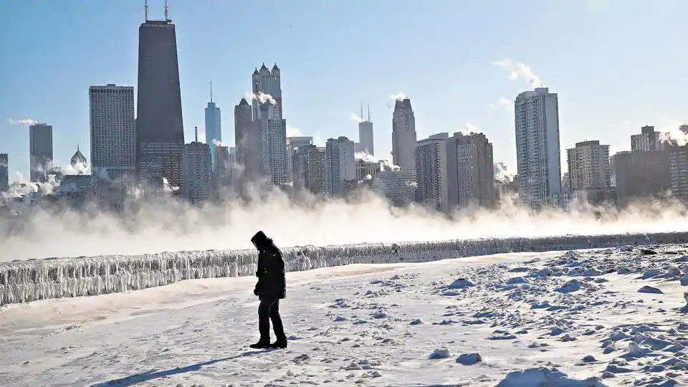

Would You Rather Questions.
- Would you rather live in a place where it is always hot or always cold?
- Would you rather have an apartment in a big city or a house in the countryside?
- Would you rather be an amazing dancer or an amazing singer?
- Would you rather live a short life and be rich or have a long life and be poor?
- Would you rather be a great writer or be great at math?
- Would you rather be deaf or blind?
- Would you rather age from the neck up only or the neck down only?
- Would you rather work really hard at an interesting job or slack off at a boring job?
- Would you rather be 10 minutes late or be 20 minutes early for everything?
- Would you rather master every musical instrument or be fluent in every language?

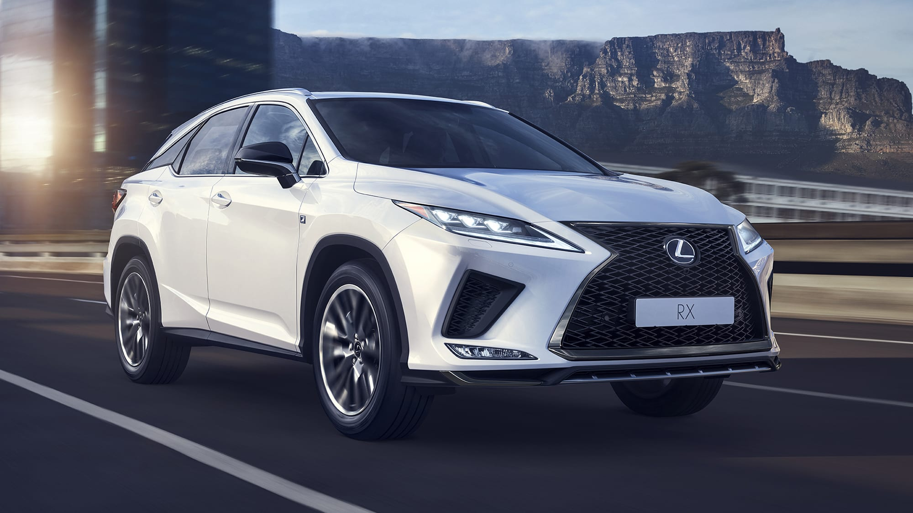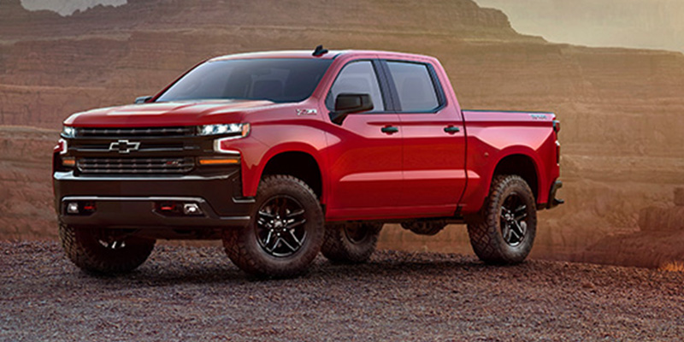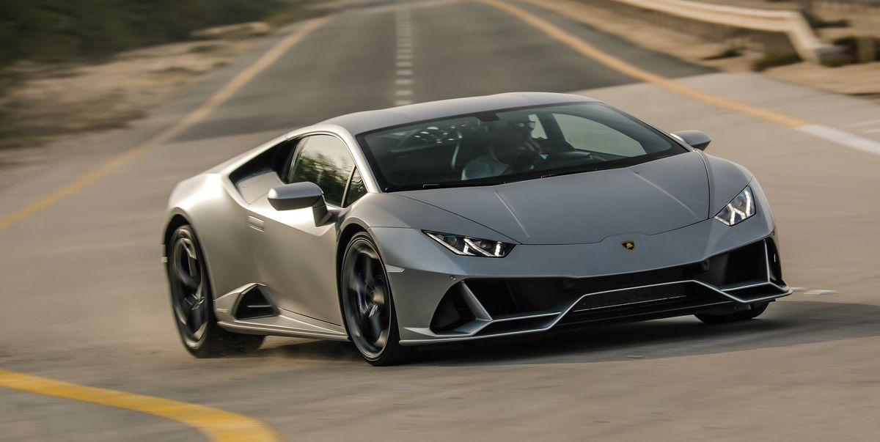

Hypotheticals.
- If you could have any car you wanted, which car would you choose?
- If you could be another person for a day, who would you be?
- If you only had a week to live, what would you do?
- If you could live anywhere, where would you live?
- If you could travel back in time, where would you go?
- If you could stop a bad habit you have, what would you stop?
- If you could be famous, what would you want to be famous for?
- If you could do any job, what would you like to do?
- If you were given three wishes, what would you wish for?
- If you could travel to any new place, where would you go?

