THURSDAY 7/16, DAY 14

PRONUNCIATION
: STRESS-TIMED

WARM-UP: 2ND CONDITIONALS

2nd conditional use.
The 2nd conditional expresses __________ situations.
2nd conditional structure.
If (_____), would/could + (_____).
Some examples.
E.g. “If I lived in Montana, I would ride horses more.”
E.g. “

ROAD TRIPS
Intro video: https://www.youtube.com/watch?v=gDv1Ex4Q5t4

READING
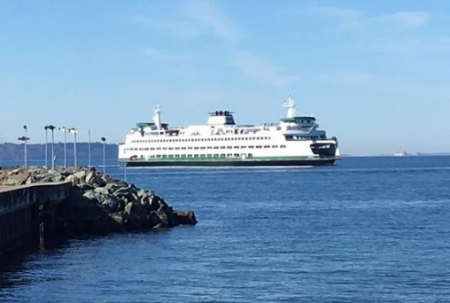
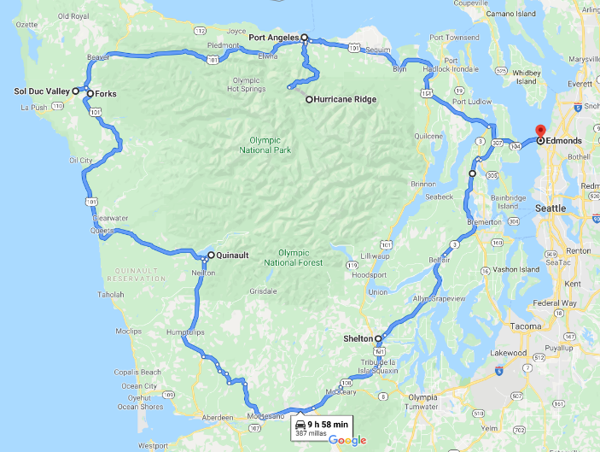
If I could go on a road trip, I would go to the Olympic Peninsula. The peninsula has many famous parks and beautiful towns. It only takes about ten hours to drive around the peninsula. I have lived in Washington for 22 years, and I have never been there! It is ridiculous because when I travel, I am so happy. I want to take this road trip with my friend, Ginger. She is fun, and she is not a backseat driver, so she is a good person to take a road trip with.
We would hit the road at 9 a.m. We could start in Seattle or Olympia, but I would start in Edmonds because my friend lives near there. Also, there is a ferry to take us across the Puget Sound.
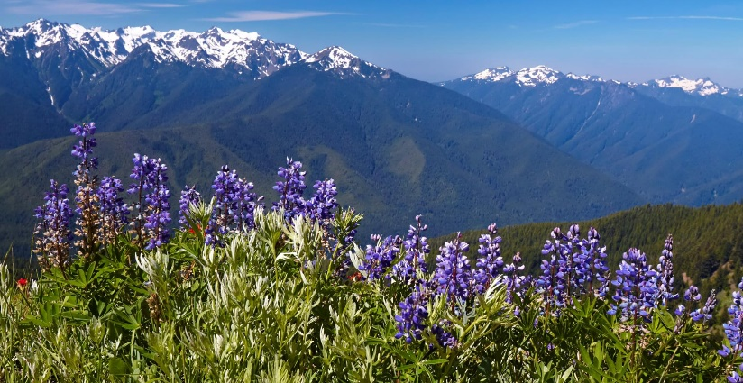
Then, we would make a pit stop in Port Angeles. The downtown is cute, and we could stop to grab some snacks or a tea. Then, we would get off the beaten path and head to Hurricane Ridge.
Ginger and I love hiking, so we would take a few hours to hike. Look how beautiful this national park is!
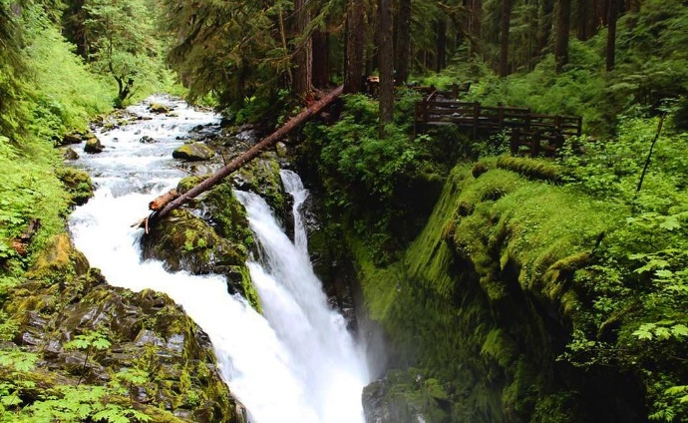
I have always wanted to see the Hoh Rainforest, so next we would stop and see Sol Duc Falls. We could take pictures, hike, or eat lunch there if we had enough time.
From there, there are more things to see, but these would be my favorites! If she has some extra vacation days, we will take this road trip in August. I think it would be an amazing experience. Where would you go if you could?

COMPREHENSION QUESTIONS
Grammar. (BR)
Find examples of conditionals in the reading.
Zero:

1st:

2nd:
- If I could go on a road trip, I would go to the Olympic Peninsula.

Some of the 2nd conditionals only have ‘one part’. Finish the second half of the conditional. This activity is flexible and open to your creativity
- “We would hit the road at 9 a.m.”
…If we took the road trip, we would hit the road at 9 a.m.
OR …If we woke up early, we would hit the road at 9 a.m. ETC.

Travelling idioms.
From the reading, what do you think these expressions mean? Use context to help you.
- to go off the beaten path: to go to a less popular destination
- to make a pit stop:
- to be a backseat driver:
- to hit the road:

Ideas.
Summarize the text in 2-3 sentences.
This reading is about…

Details.
Answer the questions with your opinions.
- Would you like to go on this road trip if you could? Why?
- Which activity or stop sounds like the most fun to you?
- Have you been to the Olympic Peninsula before?
- Do you like road trips? Where do you prefer to go?
- Do you prefer to go off the beaten path, or do you prefer to go to famous areas?
- When you travel, do you make many pit stops or drive straight through?
- Are you a backseat driver? Do you know anyone that is?
- What time do you prefer to hit the road?

