HAPPY FRIDAY! AND DAY 15.

PRONUNCIATION: COMBINING FEATURES
Definitions.
Intonation: the way the voice rises and falls for meaning.
Syllable: a unit of sound.
- Stressed syllable: longer, louder, and higher.
- Unstressed syllable: shorter and quieter. Often a /ə/ sound.
Stress-timed languages: length of time speaking = number of stresses
- Content words: nouns, main verbs, adjectives, adverbs, Q-words.

Content words.
Content words are nouns, main verbs, adjectives, adverbs, and question words.

Let’s practice.

Content words |  |  |  |  | 6. Function words
1. Nouns | 2. Main verbs | 3. Adjectives | 4. Adverbs | 5. Q-words
People, places, things | Actions | Describe nouns | Describe verbs | Word to form questions | the  of  and  a
Word  Time  home | Tell  Want  Play  Live | Hot  Happy  Slow  Small  Big | Happily  Slowly  Politely  Never | How  Why  Where

Main verbs v. Auxiliary verbs (e.g. do, has, be, can)
Main verbs control the meaning of the sentence.
Auxiliary verbs just ‘help’. Often you can contract them.
E.g. “I’m studying English.” “She’s been visiting since Monday.”

Identify the main and auxiliary verb.
1. What’re you doing? 6. I can see the dog.
2. I’m leaving. 7. Do you want to dance?
3. What do you want? 8. If you cook, I’ll clean up.
4. Where does he live? 9. If she could, she’d like to visit us.
5. We’ve eaten dinner.

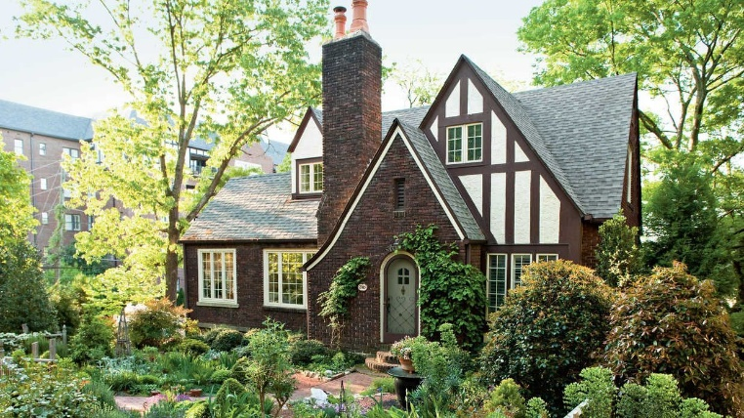
Can you combine it all?
Consider: -syllables -content words -auxiliary verbs

If I had more money, I would buy an old house. I
would renovate it, and it would be beautiful.

WARM-UP
Idioms. -hit -be -make -go off

- to __________ the beaten path a. to start a trip
- to __________ a pit stop b. to stop while driving for food,
- to __________ the road bathrooms, or gas.
- to __________ a backseat driver c. to go to a less touristy destination
d. to be a passenger in a car giving
unwanted advice.

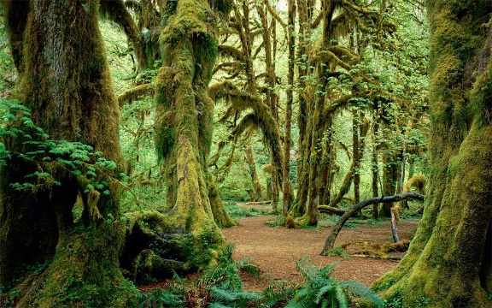
Reading.
4. The Olympic Peninsula
- Where does it go?
- What can you see?
- More notes:

FAMOUS ROAD TRIPS
Watch: https://www.youtube.com/watch?v=jGzNHZF38XQ (6:15-end)

3. The Road to Hana
- Where does it go? Maui, Hawaii
- What can you see? Sea, falls
- More notes: Natural paradise, relaxing

2. Pacific Coast Highway
- Where does it go? San Francisco to Los
Angeles/San Diego, California
- What can you see? Beaches, bridge, towns,
Redwood forest
- More notes: many coastal towns

1. Route 66
- Where does it go? Chicago to LA
- What can you see? Bars, motels, iconic
Places, classic “USA” (retro), stores
- More notes: kitschy (adj, a little cheesy but
also sentimental)

In your opinion.
- If you could, which road trip would you prefer to take? Why?
- Have you visited these places before?

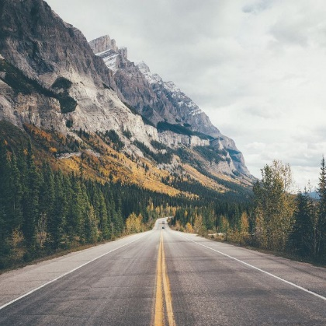
ACTIVITY
Imagine a trip you have taken or want to take. Imagine where you would go, what you would visit, and who you would go with. What would you eat? Etc. Then, like the video, create a mini summary of your favorite trip (in the past or hypothetical). Be ready to share with your group. Include pictures if you would like.
I loved when we travelled to…
If I could anywhere, I would travel to…

DISCUSSION
- Do you take many road trips? Where have you been?
- What is a road trip that you would like to take if you could?
- Are you planning your next vacation?
  - If you could, where would you go?
  - Who would you go with?
  - How long would you stay?
- Describe an interesting person you met on one of your travels.
- What was the worst trip you have been on? What happened?
- Do you like to travel with your family? Where do you go?
- Have you travelled to many foreign countries? Where? What did you see?

