Writing Email Activity

Model:

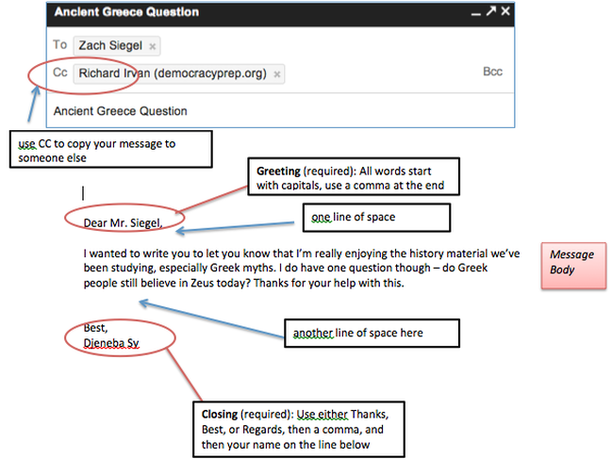
This image was taken from: http://dphmstech.weebly.com/week-5-sept-30--oct-4.html

Example:
Dear Xavier Dolan,

I wanted to write you to let you know that I am really enjoying your films, especially “Lawrence Anyways”. I would like to know what is your inspiration when you are doing your films?
Best,
Carely

Write your email. Use your conversation card as support for this activity.

Dear___________________,

________________________________________________________________________________________________________________________________________________________________________________________________________________

Best,

