Writing Email Activity
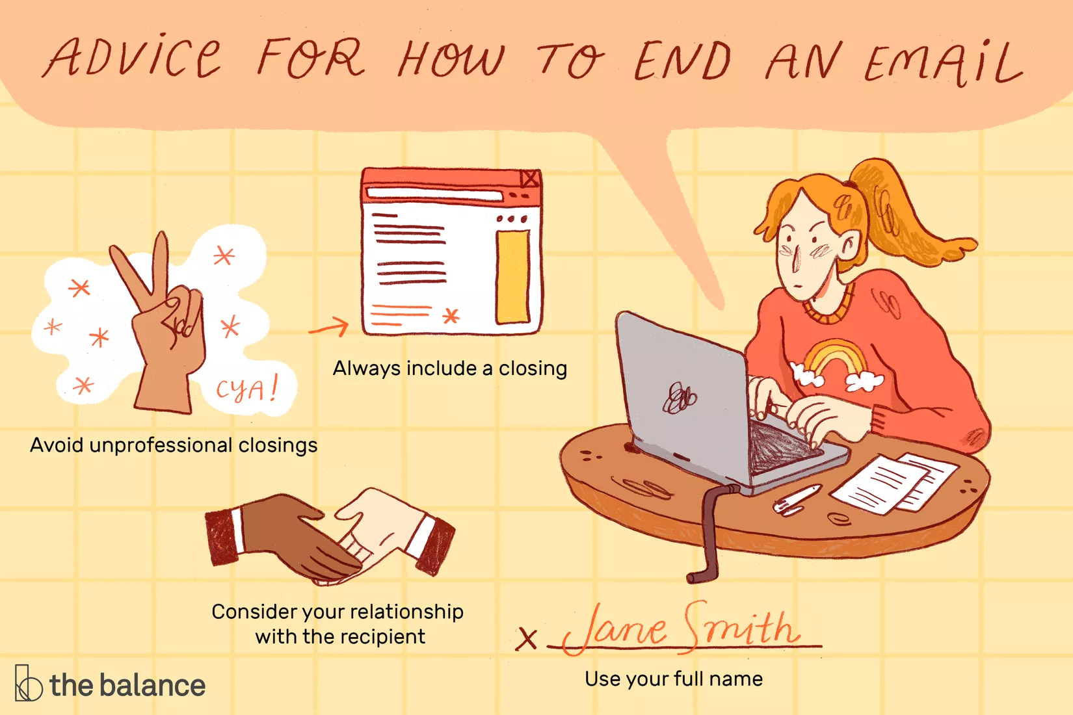
This image was taken from: https://www.thebalancecareers.com/email-message-closing-examples-2061895
Greetings Examples
Dear [Name],
Hello [Name],
Hi [Name],
When writing to three or more recipients:
Hello everyone,
Hi team,
Hello all,
When you are unsure of the recipient’s name:
Greetings,

Closing Examples
Professional Closing
All the best,
Best,
Best regards,
Best wishes,
Looking forward to hearing from you,
Regards,
Sincerely,
Sincerely yours,
Thank you,
Thanks again,
With appreciation,
With gratitude,
Yours sincerely,

Semi-Professional Email Closings
Cheers,
Faithfully,
Many thanks,
Warmly,
Yours truly,

Informal Email Closings
Love,
Talk soon,
See ya,
See ya later,
See you,
XOXO
Thx
Hugs
Emoticons

References
Indeed. (2021). Indeed. Retrieved from https://www.indeed.com/career-advice/career-development/greeting-from-email
The Balance Career. (n.d.). The Balance Career. Retrieved from The Balance Career: https://www.thebalancecareers.com/email-message-closing-examples-2061895

