Class Feedback
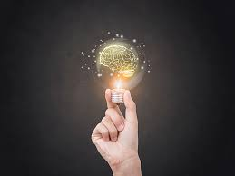 | Things I Learned Today …
 | Things I Found Interesting …
 | Question I Still Have …
 | Comments ……..

