Look at the Map. Read the sentences. Write T (True) or F (False).

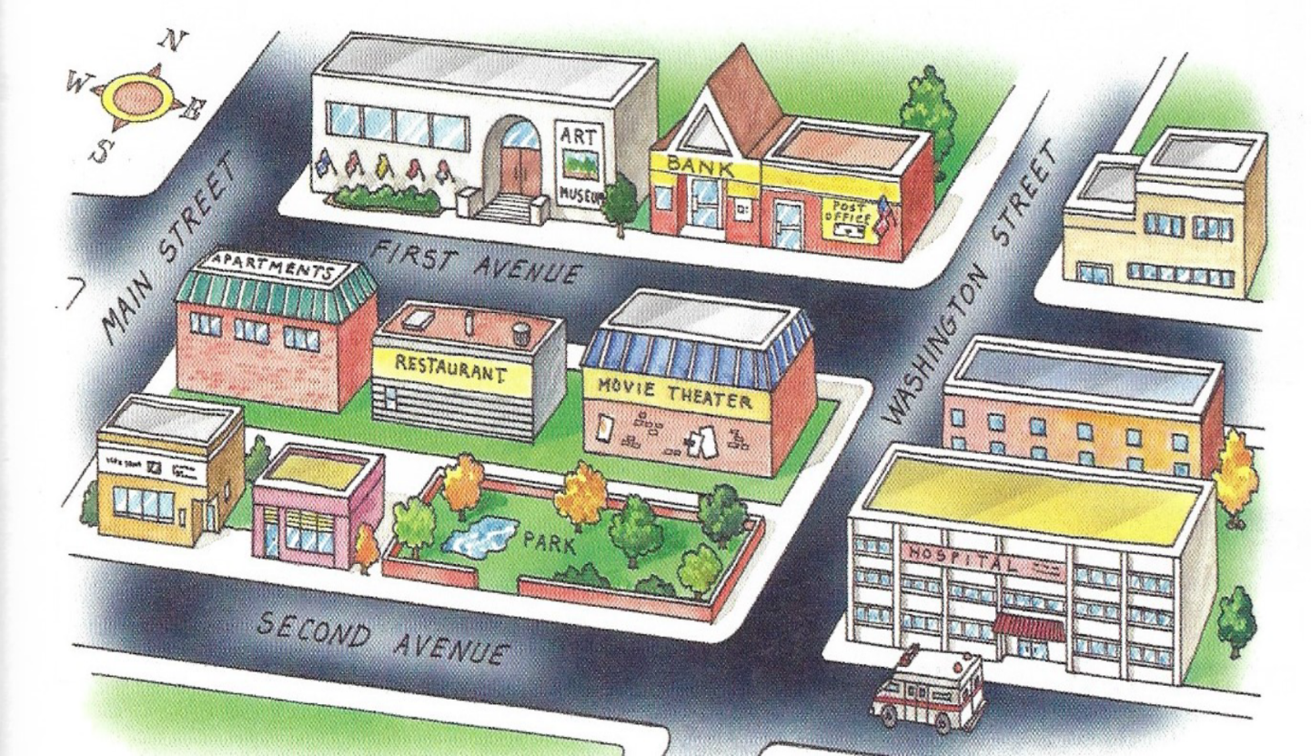

- ______ The movie theater is across from the restaurant.
- ______ The post office is next to the bank.
- ______ The bank is between the post office and the art museum.
- ______ The restaurant is on Washington Street.
- ______ The hospital is on First Avenue.
- ______ The art museum is across from the restaurant.
- ______ The park is next to the restaurant.

References
Eckstut- Didier, S. (2012). Focus On Grammar (Third ed.). New York: Pearson.

