**GECO FIRST DAY LESSON – 9/19/20**

**Questions (whole class).**

1. What is your name?
2. Where are you from?
3. Where do you live?
4. What languages do you speak?

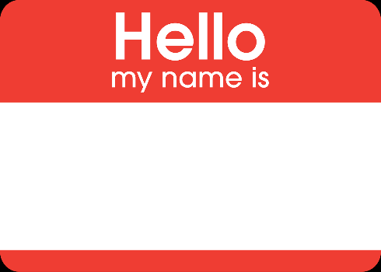 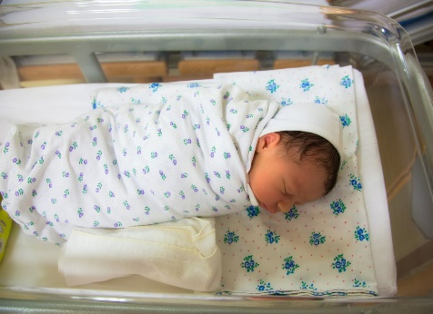 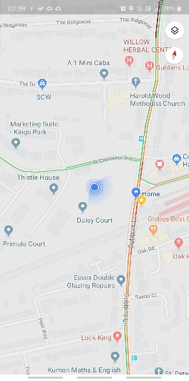 

My name is ________________.

I am from _________________.

I live in ____________________.

I speak ________________ and ________________.

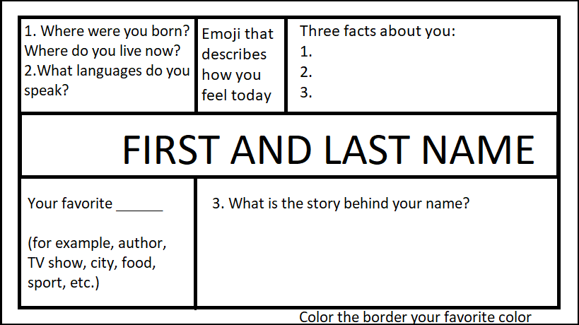

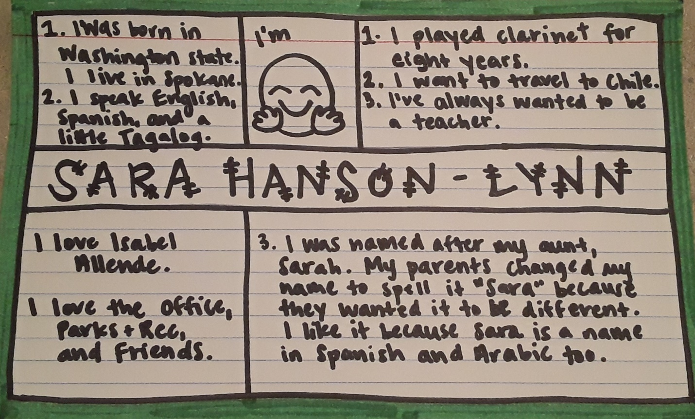

**Exit ticket:**



**From student to teacher, what do you want me to know about you?**