Name: __________________________ Date: _____________

GOAL SETTING
Studying English is fun, sometimes frustrating, and often important. In Fall GECO, we will explore unit topics like school, jobs, housing, and healthcare. To make this class as meaningful as possible, it is helpful to set goals. At the end of the class, we will reflect on the goals you set.

Helpful goals are:
- Specific (What do you want to achieve?)
- Measurable (How will you know if you have achieved it?)
- Realistic (Is it possible?)
- Time-Bound (In what time do you want to achieve this goal?)

There are different types of goals. For example:
- Academic
  - Learn new vocabulary, more easily express ideas, and thoughts, etc.
- Professional
  - Be more prepared for a job interview, learn new strategies for talking to my kid’s teachers, etc.
- Personal
  - Become more confident, learn about new cultures, learn more slang and expressions, make new friends from different countries, etc.
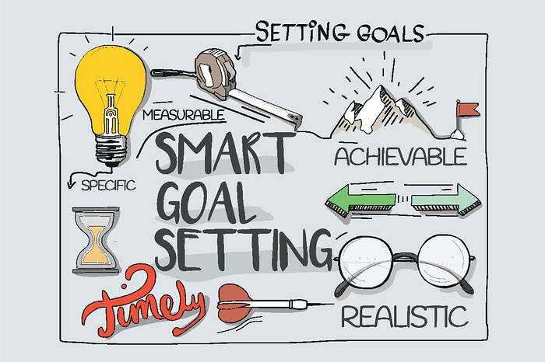
Write your goals below. Make sure they are specific, measurable, and detailed. This will make them more meaningful. For example:

Goal #1: Learn more about U.S. culture
I want to learn more about the U.S. school system. How should I talk to my kid’s teacher? How is the school organized? I want to be confident with my vocabulary in these conversations.

Goal #2: Improve my English
I want to get better at English while here, especially speaking. I will keep a notebook where I can write down new words I am learning. I will also ask for recommendations about good TV shows so I can learn more casual language. I want to watch TV without subtitles.

What goals to do you hope to achieve in GECO?
What do you want to learn from these classes?

______________________________________________________________________________
______________________________________________________________________________
______________________________________________________________________________
______________________________________________________________________________
______________________________________________________________________________
______________________________________________________________________________
______________________________________________________________________________
______________________________________________________________________________

