Vocabulary (vocabulario)

Read the definition, fill in the vocabulary word in the left column.
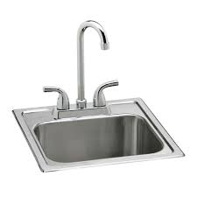
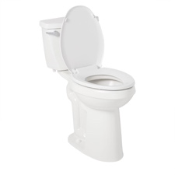
3
1
Vocabulary Word | Picture #
Refrigerator
Toilet
Oven
Shower
Dishwasher
Sink
Clogged
Broken
Drip
Drain
Leak
Rust
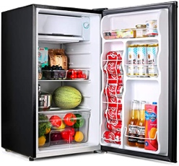
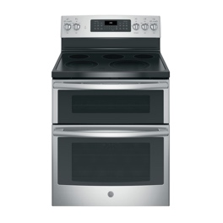
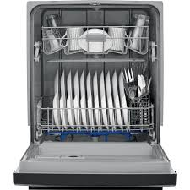
6
5
4

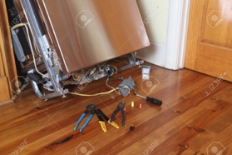
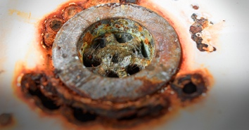
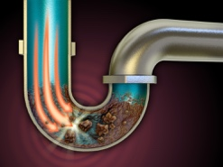
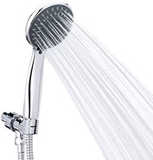
9
8
7
2
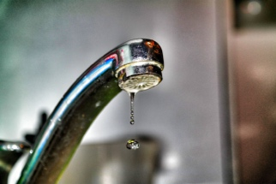
10
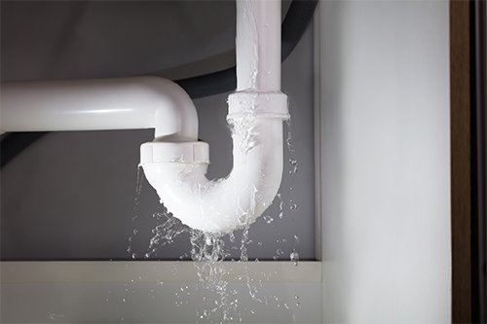
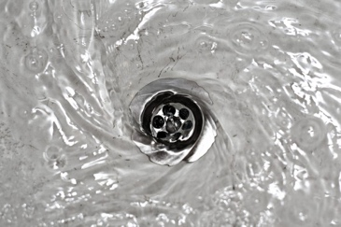
12
11

Present Progressives:
(Subject + to be + verb)
Example: The shower is leaking.

Negative Present progressive:
(Subject + to be + negative + verb)
Example: The shower is not leaking.

Use the present progressive form when you are talking about something that is or isn’t happening right now!

Using the vocabulary words as the subject, and -ing verbs, construct present progressive sentences. If you have time, construct negative present progressive sentences (The shower is not leaking). Review root of -ing verbs.

Vocabulary words: | Verb Examples:
- Toilet  - Shower  - Sink  - Dishwasher  - Oven  - Refrigerator | - Leaking  - Dripping  - Draining  - Heating  - Cooling  - Rusting  - Clogging  - Breaking

Making Appointments Using “Can” Questions:

Example: Can you help me on Tuesday at 2?

____ you help me on ______ at ___?

