PRACTICE USING CONDITIONALS

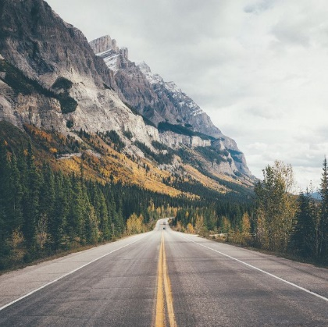
Imagine a trip you would love to take. Then, like my text about visiting the Olympic Peninsula (from Thursday’s class), create a mini summary of your hypothetical trip. Include pictures if you would like!
Ideas of what to include:
- Where you would go
- What you would visit
- Who you would go with
- How long you would go for
- What you would see
- Etc.

Try to use a zero, a 1st, and many 2nd conditionals to describe your trip. This is your opportunity to experiment with the grammar, idioms, and travel ideas we have talked about this week

If I could anywhere, I would travel to…

