Name: ________________________________

“From novelty to necessity: The growing tiny home movement” Post-Reading Activity (Jones, 2019)

Rewrite the title in your own words. You already did this in the
breakout rooms; now, decide on a reworded title in your group.

Our title: __________________________________

Answer the comprehension questions with full sentences.

- Are tiny homes a new or old movement? ________________________________
- Who is behind the movement? __________________________________
- What is the movement in response to? _________________________________
- How small is a tiny home? __________________________________
- How does the cost of owning and building a tiny home compare to a traditional home? __________________________________
- What are other types of tiny housing? __________________________________

Answer the analysis questions with full sentences:

The article says tiny homes reduce energy consumption by up to 45%, but it doesn’t give reasons. So, you think: what are some reasons a tiny home might use less energy?
- __________________________________
- __________________________________
- __________________________________
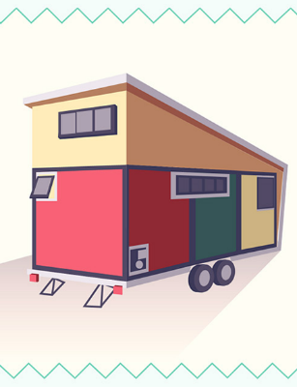
The article gives many advantages of living in tiny homes. However, the article doesn’t list any consequences.

Write the benefits from the article below. Add any consequences or additional benefits you can think of. Write you additions in blue.

(Try to use the vocabulary from the warm-up: trailer, benefit, stability, debt, shrink, novelty, soar, expenses, dwelling)

Benefits | Consequences

