HOMEWORK DAY 5 – FINAL DIALOGUE

We have studied politeness, making requests, and greetings this week. Here, you can see it all combined. For the final practice, analyze my dialogue and then create your own.
PART ONE: MY DIALOGUE

Context:
Employee to boss.
Situation: You have been working at your job for over a year. You have more responsibilities now, and you want a raise. You make $18/hour now, and you want $20/hour.

1. Choosing politeness level: Select one option that describes my context.
- Relationship: intimate/distant
- Status: high/low
- Formality: formal/informal
- Request: big/small

2. Choosing language:
What type of request should be used (direct/indirect/hint)? Why?
Because it’s formal and it’s a big request. Also the boss has higher status.

3. Analyze the dialogue.
Color code my dialogue to identify the different politeness technique I’m using.
- Color the request purple.
- Color and highlight softeners:
- Prepare them
- Get precommitment
- Give a reason
- Acknowledge them
- Promise reward
- Minimize imposition
- Use word softeners: please, um, just, only, okay

THE DIALOGUE (E=employee, B=boss)
E: Hello, good afternoon.
B: Hi. What’s up?
E: Do you have a minute?
B: Sure, come in.
E: How’s your day going?
B: It’s alright, you?
E: It’s good. So, I was wondering if I could talk to you about my salary. We just had my annual performance review, and you said you were satisfied with my work. Would now be an okay time to discuss this?
B: Sure, take a seat.
E: I’ve been working here for over a year, and I really love it. I also have more responsibilities now. Would it be possible to discuss a raise, please?
B: That’s true and yes. What did you have in mind?
E: I currently make $18 an hour. I know other people with my experience and job responsibilities are making $20 an hour. If that is within the budget, I feel like it would be a fair raise.
B: Hmm. I’ll have to think about it. Give me a couple days to look over the budget, and I will tell you by Friday.
E: That’s great, thank you so much.
B: Alright.
E: Okay… Thanks again. Talk to you later.
B: Mhmm, have a nice day.

PART TWO: CREATE YOUR OWN DIALOGUE.
4. Choose one situation:
#1 Employee to boss.
Situation: Your mother is coming to visit you this weekend. On Monday, she flies out of the airport and you want to take her to your flight. You would arrive three hours late to work. You want permission to come late.
OR
#2 Boss to employee.
Situation: Your employee is working more hours than they are supposed to. Every day, they clock out about five minutes late. They are not currently approved for overtime. You want them to clock off on time.

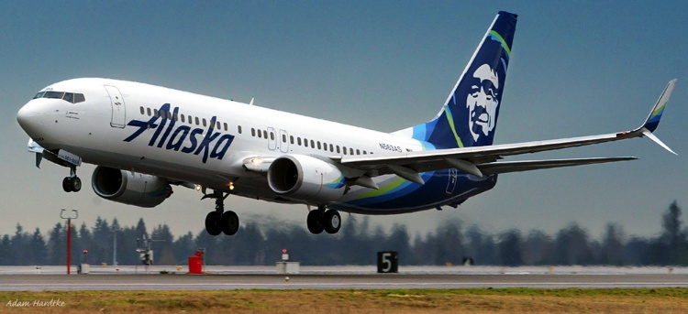

Then, do the same process Part One for your own dialogue. Show me where you include softeners and your request.

5. Choosing politeness level: Select for your dialogue.
- Relationship: intimate/distant
- Status: high/low
- Formality: formal/informal
- Request: big/small

6. Choosing language:
What type of request should be used (direct/indirect/hint)? Why?

7. Write, then analyze your dialogue.
After writing your dialogue below, color code it to show me the different politeness technique you’re using.
- Color the request purple.
- Color and highlight softeners:
- Prepare them
- Get precommitment
- Give a reason
- Acknowledge them
- Promise reward
- Minimize imposition
- Use word softeners: please, um, just, only, okay

My dialogue:

