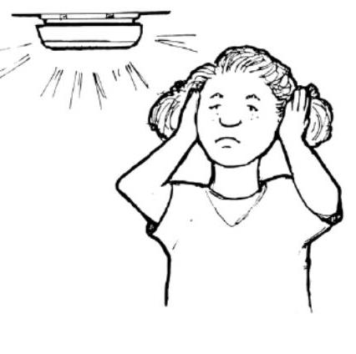
I CAN’T SLEEP!!!
Mark lives in an apartment. He has a daughter. Her name is Margo.
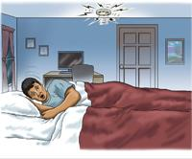
Mark and Margo are sleeping. They hear a loud noise. BEEP, BEEP, BEEP. It is dark in the bedroom. Mark can’t see. He turns on the light. Now it is quiet.
Mark and Margo go back to sleep. The noise starts again. BEEP, BEEP, BEEP. Mark turns on the light. He sees the smoke alarm. It is beeping! But there is no smoke. There is no fire. Mark doesn’t understand. What’s the matter?
All night the smoke alarm beeps. It starts and it stops. It is hard to sleep. In the morning Margo is very tired. Mark calls the apartment manager.
“I have a problem,” Mark says.
“What’s the matter?” asks the manager.
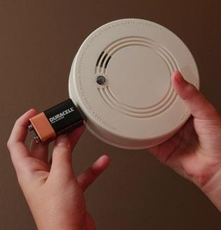
“My smoke alarm is broken. It is beeping but there is no fire,” Mark says.
“It needs a new battery,” says the manager. “I can come tomorrow.”
“It is hard to sleep,” says Mark. “Please come today!”

Part 1- Change the details of the story below into the simple past.

1. Mark lives in an apartment.

2. Mark and Margo are sleeping.

3. They hear a loud noise.

4. It is dark in the bedroom.

5. Mark turns on the light.

6. The noise stops.

7. Mark and Margo go back to sleep.

8. The noise starts again.

9. Mark turns on the light.

10. He sees the smoke alarm.

11. It is beeping but there is no smoke.

12. In the morning Mark calls the apartment manager.

13. Mark asks the apartment manager to come fix the smoke alarm.

Part 2- Reading Comprehension:

- What was Mark’s problem?

- What was Mark’s request?

- Do you think Mark’s request was polite? If yes, why?
If no, how could he make his request more polite?

Part 3- Discuss the questions below.

- Have you ever had a problem with your home/apartment?

- What was the problem?

- How did you solve it?

