WARM-UP

Vocabulary PowerPoint

LESSON

PowerPoint: How to Dress for a Job Interview

Video: Step Brothers – Job Interview

Discussion Questions

- How would you rate the job interview you just watched?

(Very Good, Good, Bad, Really Bad)

- Provide examples of why you rated the job interview the way you did?

How to Navigate the Job Interview

An interview is your opportunity to learn more about an employer and the available job. Preparation is key to your success. Before the interview, gather facts about the company. This will help you answer potential interview questions. It also gives you important information on how to match your skills to the company or position.

Before the Interview

Review common interview questions.
- Tell me about yourself.
- Why are you interested in working for this company?
- What are your strengths?
- What is your major weakness?
- How do you think you will fit into our company?

Arriving to the Interview
- Plan your schedule so you arrive 10 to 15 minutes early.
- Go by yourself.
- Look professional. Dress in a manner appropriate to the job.
- Turn off your cell phone.

During the Interview
- Shake hands firmly, but only if a hand is offered to you first.
- Maintain eye contact.
- Listen carefully. Welcome all questions, even the difficult ones, with a smile.
- Give honest, direct answers.
- If you don't understand a question, ask for it to be repeated or clarified.

Ending the Interview
- Be courteous and allow the interview to end on time.
- Find out if there will be additional interviews.
- Ask when the employer plans to make a decision.
- Indicate a time when you may contact the employer to learn of the decision.

After the Interview
Send a thank-you note or letter after the interview.
- Write the note no later than 24 hours after the interview, even if the interview didn’t go well.
- Be brief but include the following information.
  - Statement of appreciation for the opportunity
  - Expression of continued interest in the job
  - Additional background you may have failed to mention
  - Date and time you will follow up as previously agreed

Reading Activity

Directions: For each task, decide whether the task is done “before, during, or after the interview.”

Before (Arriving), During (Ending), After | Task
 | Turn off your cell phone.
 | Ask when the employer will make a decision.
 | Review interview questions you may be asked.
 | Send the employer a thank-you letter.
 | Give honest, direct answers to questions.

Video: Illegal Interview Questions to Watch Out for

Legal or illegal? That is the Question!

Legal or illegal | Question
 | Are you Catholic or Jewish?
 | Why were you fired from your previous job?
 | Do you have a pre-existing medical condition?
 | Are you, or are you over, the age of 18?
 | Are you a citizen of the United States?

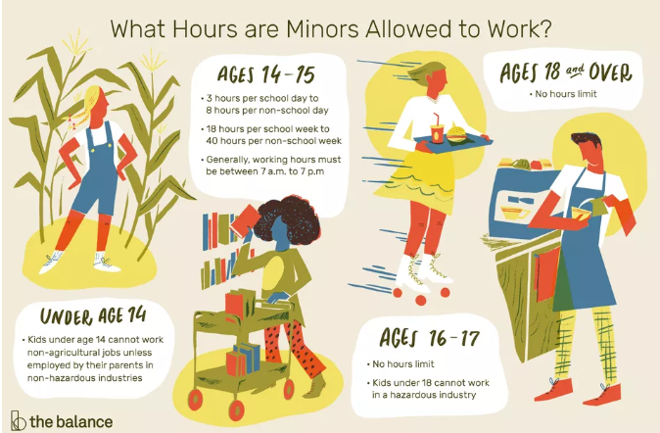

Note: Employers can also ask if you are over the age of 21 if the job involves serving alcohol (bartender).

Some examples of potentially unlawful immigration or citizenship status discrimination include:
- You didn't get hired because the employer hires only U.S. citizens to do certain jobs.
- You are a temporary resident with work authorization, but a company denies you employment because it doesn't want to deal with the “hassle” of filling out the appropriate paperwork.
- Muslim, Asian and Latino employees are asked for copies of their work authorization papers, while other employees who are Caucasian or African-American are not asked to provide similar authorization papers.
- You show your employer your driver's license and social security card, but your supervisor insists that you also show her a copy of your green card. When you point out that this is not required by law to fill out the I-9 form, you are told the company requires it.
- You sign up with a temporary agency, and learn that a certain employer has work for someone with your skills and experience. The agency refuses to refer you to work for this employer because the employer wants to hire only U.S. citizens.
Extension: Job Interview

Directions: Students should take about 8-10 minutes to read the following questions and prepare how to respond to those questions.

- Tell me about yourself.
- What are your strengths?
- What is one of your weaknesses?
- Why do you think you would be a good fit for our company?
- Why are you the best person for the job?

Mock Interview Script:

Interviewer = Person asking the questions Interviewee: Person answering questions

Interviewer: Hi (Interviewee’s name). My name is (Interviewer’s name), and I will be conducting your interview today. Let’s go ahead and get started.

Interviewer: First, go ahead and tell me about yourself, (Interviewee’s name).

Interviewee: (interviewee answers the question)

Interviewer: Can you please tell me about some of your strengths?

Interviewee: (interviewee answers the question)

Interviewer: What would you say is one of your weaknesses?

Interviewee: (interviewee answers the question)

Interviewer: Why do you think you would be a good fit for our company?

Interviewee: (interviewee answers the question)

Interviewer: Why are you the best person for the job?

Interviewee: (interviewee answers the question)

Interviewer: Well, (interviewee’s name), I think that’s all the questions I have. Do you have any questions for me?

Interviewee: Yes. When do you expect to make a decision on hiring?

Interviewer: You should receive a call or email within 5-7 days once we have completed all our interviews.

Interviewee: Okay. Thank you for your time.

Interviewer: Thank you, too.

https://www.careeronestop.org/JobSearch/Interview/interview-tips.aspx
https://www.workplacefairness.org/immigration-status#1

