IT’S FRIDAY! DAY 10 OF CLASS

ALTERNATIVE HOUSING IN THE U.S.
“While wages (money per hour for work) in the US have largely remained stagnant (static), the cost of basic necessities (necessary things to live) such as food, gas, and housing have been increasing”.

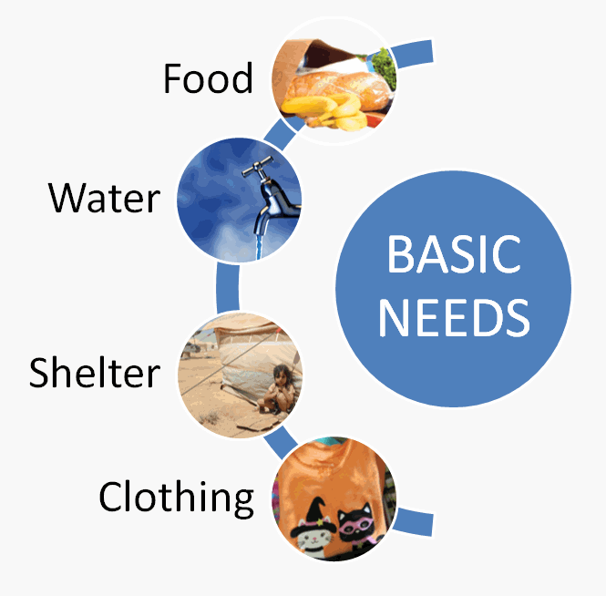

Brainstorm alternative housing options: BUS, VAN, TINY HOME
Typical housing: HOUSE, HOME, APARTMENT, TOWNHOUSE, CABIN

Later, we will watch a video about a couple from Chicago. Their wages didn’t pay enough, so they moved into a school bus. They renovated the bus, built custom furniture, and now live and work in it.

WARM-UP: WORD STRESS
Define.
Intonation: Voice goes up or goes down
Syllable: one unit of sound in one word
Word stress: the syllable in one word that is pronounced louder, longer, and higher.

Count the syllables.
renovate gas furniture wages
stagnant necessities housing increase cost
One syllable | Two syllables | Three syllables | Four syllables
Gas  cost | Wa/ges  Stag/nant  Hou/sing  In/crease | Re/no/vate  Fur/ni/ture | Ne/ces/si/ties

Match the word to the definitions.
- Renovate (v) C a. the amount worth in money.
- Increase (v) e b. to not change.
- Cost (v/n) a c. to repair and rebuild to make nicer.
- Furniture (n) g d. the money you make per hour.
- Wages (n) d e. to have more of, to raise.
- Necessities (n) f f. the basic things you must have to survive.
- Stagnant (adj) b g. e.g. couch, table, desk.

Add the word stress.
Re/no/vate gas fur/ni/ture
Stag/nant ne/ces/si/ties cost

2 SYLLABLE VERB: STRESS ON 2ND SYLLABLE: in/crease
2 SYLLABLE NOUN: STRESS ON 1ST SYLLABLE: wa/ges, hou/sing

ALTERNATIVE HOUSING VIDEO
Watch the video about Julie and Andrew.
https://www.youtube.com/watch?v=O5VaLujbod0

1st time: What are your thoughts? What is the main idea?

2nd time: Listen and choose true or false. Correct the false sentences.
- They weren’t making enough money to live in the city. true - false
- They had to work 30 hours a week. true - false
- They found a bus for $13,000. true - false
- The bus is about 200 square feet (~18 square meters). true - false
- First six months were hard to adjust to living in the bus. true – false
- Now, they live in a city where Andrew works. true - false

Discussion.
In the video, Julie mentioned they were:
- “wasting the best years of our life”
- “cooped up in an office”
- “neck-deep in rent”
What do you think these expressions mean? Have you ever felt this way?
Why did they choose to live in a bus? What do you think about their idea? Would you ever live in alternative housing? What are the pros and cons of living in a tiny home?

Adapted from: Justa (2018) https://eslbrains.com/how-to-escape-a-high-cost-of-housing/

