Warm-up Questions

In your breakout room, discuss:
- What is the story behind your name? Describe how your parents chose your name.
- Do you like your name? If you could change your name, would you? If so, what would you change it to?

- What emotion best describes you today?

Pronunciation
Listen to how these questions are said. There are two different intonation patterns. Try to group the questions into two groups. Can you create a rule for each group?

Group one | Group two
Rule: WH questions (information questions)  DOWN AT THE END | Rule: yes/no questions  UP AT THE END
Questions:  - How are you doing? (down)  - What’s up? (down/flat)  - What’s wrong? (down)  - What is the story behind your name?  - What would you change it to?  - What emotion best describes you today? | Questions:  - Are you okay? (up)  - Are you excited? (up)  - Is something wrong? (up)  - Do you like your name?

“Intonation”: how the voice goes up and down when talking to express meaning.

How are you doing? Are you okay?
Emotions and Idioms
REVIEW

In your opinion, where do the emotions go into the chart? Put them in/categorize them.
Strength | 😄 | 😠 | ☹️ | 😧
Strong  Use: super, so, very (to make stronger) | ecstatic  so happy | furious  Very frustrated  Very upset | Disappointed | Anxious  scared
Normal | happy | Annoyed  disappointed Frustrated  Upset | Anxious | anxious
Mild  Use: kind of, sort of (to make weaker) | happy | annoyed | Upset | nervous

IDIOMS

Feeling upset
If you are fed up with something, you are annoyed, frustrated, or tired of it.
You were patient before, but now you’re tired of it.
“I’m fed up with your attitude. Stop complaining”.
“You’re fed up with homework. You don’t want to study anymore”.
“I’m fed up” = “I’m so annoyed”

Feeling happy
If something makes your day, it makes you feel very happy.
“My student brought me a flower, and it made my day”.
“I slept in and it made my day”
“It makes my day when the sun is shining”
*If you just say, “it made my day”, I know you mean in a positive way.
You can also say, “My car broke down, and it made my day horrible” for negative things.

Feeling sad
If you are bummed out, you are disappointed or discouraged after an event.
“I got a D on my exam, and I’m feeling bummed out”.
“It bums me out when my friends cancel, when I can’t find any
sweets in my home, or when I come home and the kitchen is so messy.”

Feeling scared
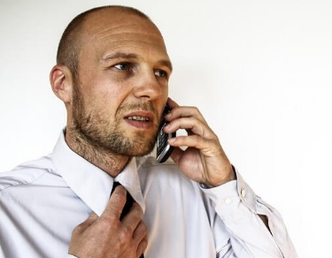
If you have a sinking feeling, you feel something bad is going to happen.
“My work is having money problems, and I have a sinking feeling
they will lay me off”.
“My birthday party is outside today, but it’s starting to get cloudy
and I have a sinking feeling it’s going to rain.”
*a sinking feeling = negative things
*a feeling = anything (e.g. “I have a feeling that my friends are throwing me a surprise party”)

Match the idioms with an emotion.
To be fed up: annoyed, furious
To make your day: happy, ecstatic
To be bummed out: disappointed
To have a sinking feeling: nervous, anxious

In your breakout groups, try to create one more example for each idiom.

