DAY FIVE LESSON
OPENING QUESTIONS
Emotions – to discuss in your breakout group.
- Is there an emotion that is more pleasant (enjoyable) or more challenging for you?
- Is there an emotion that is easier to express? Harder to express?
- Does expressing emotions change by gender? Age?
- Are you very expressive with your emotions? Why or why not?
“To have a sinking feeling”
Dread (N, V) – “I’m dreading talking to my boss” (dread – (rhymes with red))
I dread having these conversations because you always insist on putting the blame on me.
I dread having conversations about family.

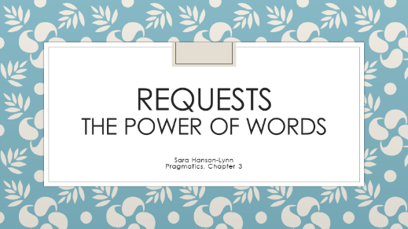

WARM-UP
Friend to friend. Situation: You are hanging out with a good friend Friday night. You want to know if it is okay to sleep at their house after because they live far away from your house.
Sort the sentences.
- Is it possible if I sleep at your house? Just for a night.
- Umm…I feel so sleepy, I don’t think I can drive, it’s pretty late at night. Yawn…
- Can I sleep over at your place?
- It’s so late, can you give me a solution?
- I don’t think I can drive now, it’s pretty late. Can I sleep at your house, please? If you don’t mind though.
- Can I sleep over at your place, please? It would be helpful.
Softness | Direct | Indirect | Hint
Not softened
Softened

LET’S PUT IT ALL TOGETHER.
Greetings:
Formal | Good afternoon/evening
Average | Hello, How’ve you been?, How’re you doing?, How’s everything?, How’s your day going?, Good morning
Casual | Hey, What’s up?, What’s new?, (Howya doin’?), How’s life?, Hi

“Positive vibes only”
Greeting type
Greeting | What’s up?, What’s new? | How’ve you been?, How’re you doing?, How’s everything?, How’s your day going? | Hi
Response | not much – nothing | Great – good – fine – okay | (Anything)
What’s up? Not much, you? Oh, just… cooking dinner. Working out.
Responses:

For example:
1: Hey! 1: Hi, how are you?
2: Hi, what’s up? 2: I’m good, you?
1: Not much, you? 1: Fine.
2: Just cleaning my house.

When do I actually respond to this question?

1: Hey! How’ve you been? 1: Hi, long time no see! How’s life? 1: Hey, how’s it going?
2: I’ve been okay. You? 2: Great. I got a new job! 2: Actually, I wanted to talk
1: Just okay? 1: Wow, no way! to you about…
2: Well…

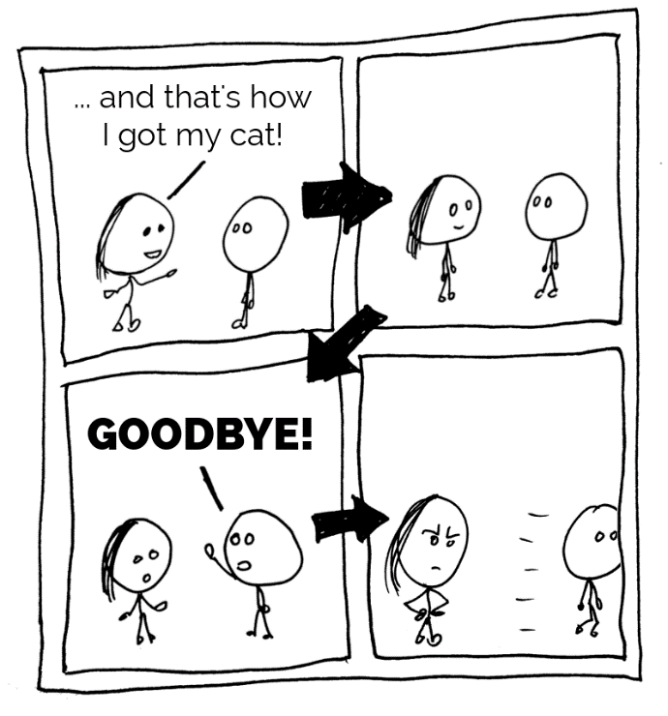
Goodbyes: How to end a conversation in English

I don’t think so. That is pretty rude, right?

We usually have what I call “pre-byes” — phrases we use to show that we’re about to leave the conversation. We use them just before saying goodbye.

Here’s how they look:

Signal word | Pre-goodbye
Okay... | Nice talking with you.
Right... | I’ve got to go / run.
Alright, then... | Great to see you.
Well… | I’ll let you get back to…
(pause)

(From https://www.clarkandmiller.com/ways-to-say-goodbye-in-english/)

Goodbyes:
Formal
Average | Goodbye, Goodnight
Casual | Bye, See you later, Talk to you later, Take it easy

For example:
1: …And that’s what I did this weekend.
2: That’s awesome! Well… I’ll let you get back to work.
1: Okay, sounds good, I have so much to do. I’ll talk to you later.
2: Okay. Bye!
1: See ya!

UNIT QUIZ AND FINAL DIALOGUE HOMEWORK
Quiz is at: https://forms.gle/3BP1FbwMNQYNkBo18

