WELCOME TO DAY SIX!

Welcome SIPs! Let’s do some introductions.
- What is your name?
- Where were you born and raised?
- What languages do you speak?

Week Two is about housing. Let’s warm up with some questions (BR).
- Where do you live?
- Do you like where you are living? Why or why not?
- What is the neighborhood like? What about your neighbors?
- Who do you live with? Do you have any pets?
- Would you prefer to live in a house or an apartment? Why?
- How are homes different in other countries?

NEW UNIT: HOUSING

Housing vocabulary: Brainstorm
People “Contact management” “Sincerely, Management” = the team that manages
…that manage the property: manager, landlord
…that own the property: landlord, owner
…that rent the property: renter, tenant

…that fix/repair things: handyman, repairman
…like toilets: plumber
…like lighting: electrician

Maintenance issues “Call Maintenance”
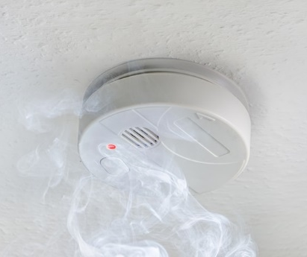
1. 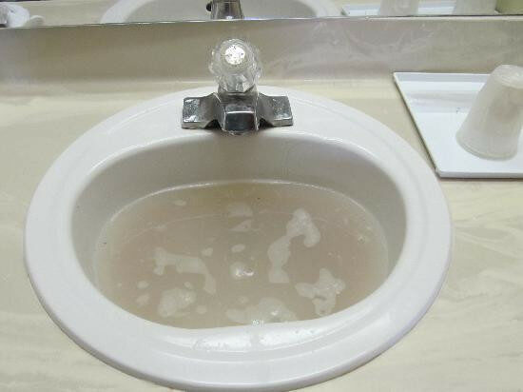 2. 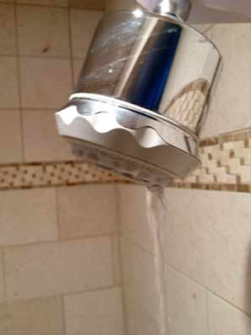 3. 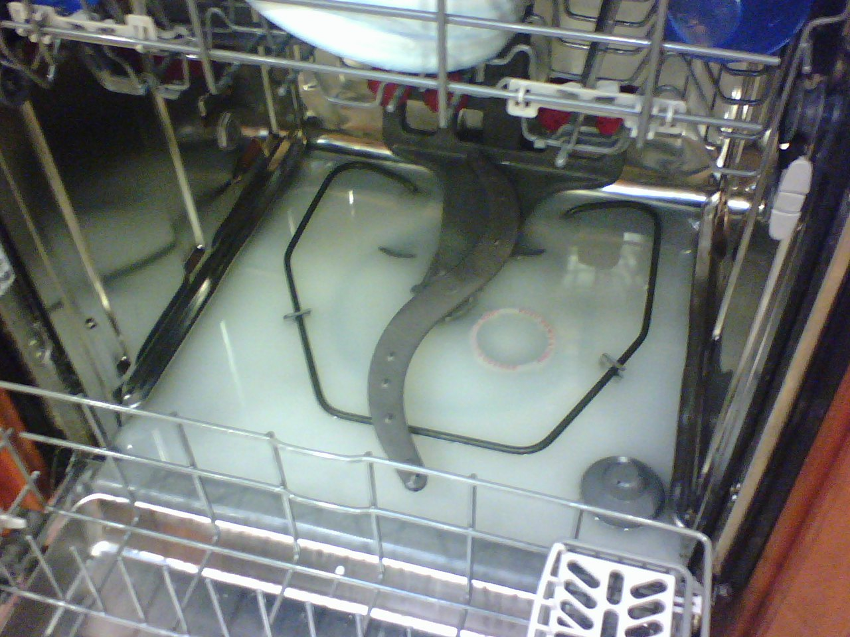
4 fire alarm/smoke detector

- Broken 2, 3 d) Not draining 1, 3
- Clogged/backed up 1 e) Beeping/going off 4
- Leaking 2

Describe the pictures and who will fix it:
- The sink isn’t draining. I think it’s clogged. Could you please send a plumber?
- The shower is leaking. Could you please send a repairman?
- My dishwasher is broken. I think it’s not draining. It’s backed up. Can you send me somebody to repair it?
- The alarm in my apartment is not working. The batteries are dead and it’s beeping. Can you please come to repair it?

GRAMMAR
Present Perfect
We use this for things that happened in the past at an unknown time and are still connected to the present.

For example:
“I have eaten frog legs” (unknown time)
“I have lived in Spokane for 11 months” (connected to the present)
Compare to:
“I ate frog legs a few years ago” (known time)
“I lived in Bellingham for three years” (finished in past)

Rules:
I have unclogged my sink. Subject + have/has + verb in past participle
She has drained the bathtub.

You have not broken the stove. Subject + have/has + not + verb in past participle
The shower has not stopped leaking. Have not = haven’t has not = hasn’t

Have you changed the batteries in the smoke alarm?
Have you fixed the dishwasher? Have/Has + subject + verb in past participle + ?

Forming the past participle:
Regular verbs: add -ed (like past)
I clog the sink.
I clogged the sink yesterday.
I have clogged the sink before.
Clogged, stopped, drained, beeped, leaked, fixed, owned, rented, started, changed

Irregular verbs: Break, go, buy, be
Break – broke – broken
Go – went – gone
Buy – bought – bought
Am/are/is – was/were - been

PRACTICE
Make sentences (BR)
Subject + have/has + verb in past participle
Subject + have/has + not + verb in past participle
Have/Has + subject + verb in past participle + ?

Have vs. has: I have, you have, she/he/it has, we have, they have

- (I, break, window) I have broken the window.
- (You, fix, TV)
- (The internet, stop working)
- (The shower, start leaking)
- (I, not, drain, bathtub) I have not drained the bathtub.
- (We, not, change, batteries)
- (You, not, clog, toilet)
- (He, drain, sink?) Has he drained the sink?
- (The alarm, start beeping?)
- (You, break, fridge?)

HOMEWORK

An explanation: https://www.perfect-english-grammar.com/present-perfect.html
More practice: https://www.perfect-english-grammar.com/present-perfect-exercises.html

