IT’S DAY SEVEN!

CORRECT THE ACTIVITY
Our rules:
Subject + have/has + verb in past participle
Subject + have/has + not + verb in past participle
Have/Has + subject + verb in past participle + ?

Have vs. has: I have, you have, she/he/it has, we have, they have
- (I, break, window) I have broken the window.
- (You, fix, TV) You have fixed that TV.
- (The internet, stop working) The internet has stopped working.
- (The shower, start leaking) The shower has started leaking.
- (I, not, drain, bathtub) I have not drained the bathtub.
- (We, not, change, batteries) We have not changed the batteries.
- (You, not, clog, toilet) You haven’t clogged the toilet.
- (He, drain, sink?) Has he drained the sink?
- (The alarm, start beeping?) Has the alarm started beeping?
- (You, break, fridge?) Have you broken the fridge?

DID vs. WAS vs. WH-
We use “was” for questions with the “to be” verb. We use “did” for other verbs unless it’s a WH- question.
For example:
“Were you at the store?” – “I was at the store.”
“Did you go to the store?” – “I went to the store.”
“Where were you?” – “I was at the store.”
“Where did you go?” – “I went to the store.”
Practice:
- What did you eat? - I ate chips. What did you do last night? Where did you go?
- Were you hungry? - Yes, I was. Were you tired?
- Did you eat? - Yes. Did you sleep well? Did you work last night?

Warm-up: SIPs on making requests

LISTENING
What are some common repairs people do in their apartments or houses? What can go wrong with the carpet, windows, appliances, toilet, or sink?
Sink/toilet: clogged, not draining, backed up
Appliances: not working, short circuiting
Window: broken
Carpet: wet, dirty, ripped, smelly/stinky, moldy, stained

3 Missing windowpane, 1 stained carpet, 5 tile needs replacing, 4 central heating went out,
2 leaking faucet
1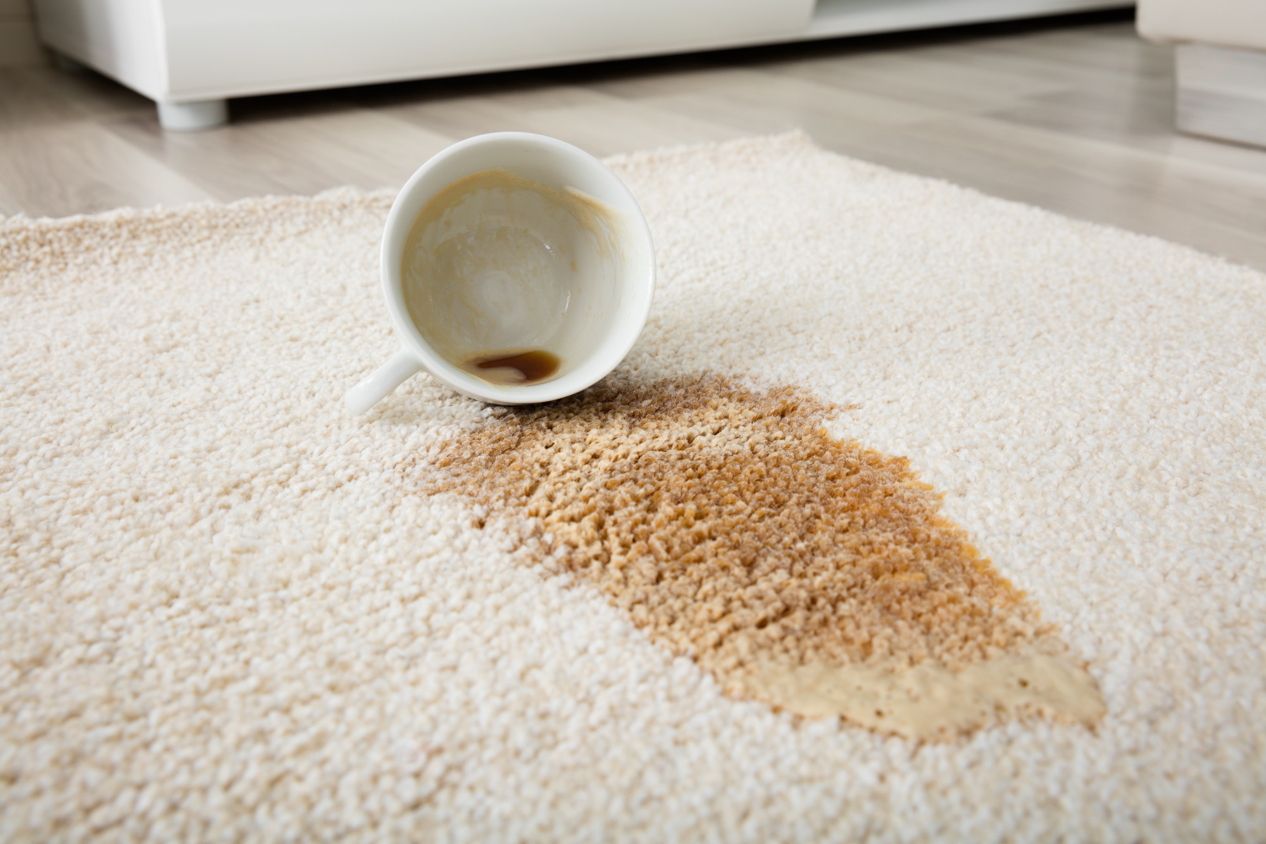 2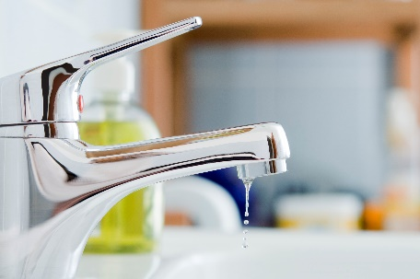 3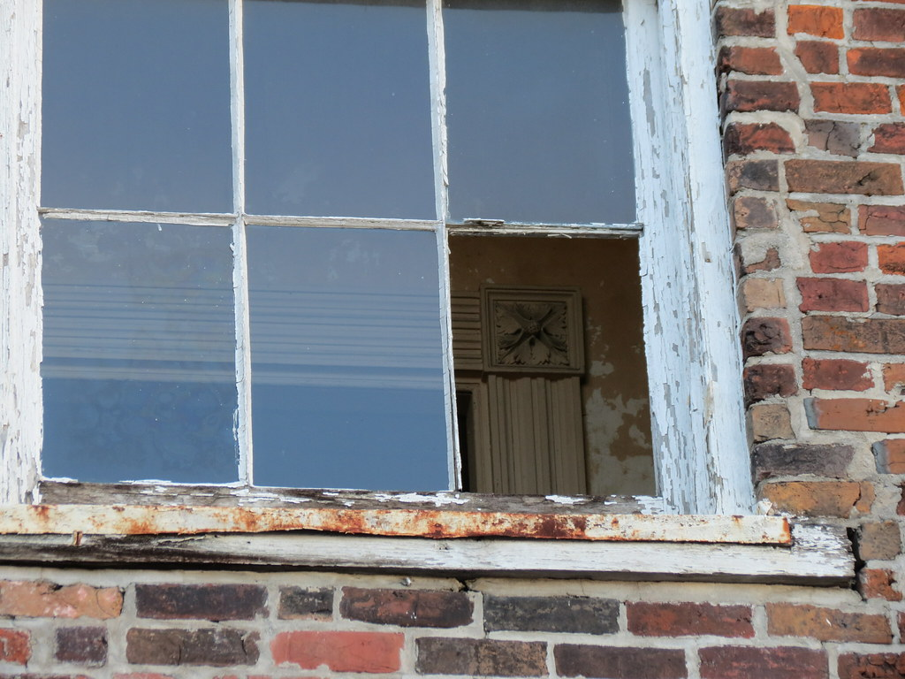
4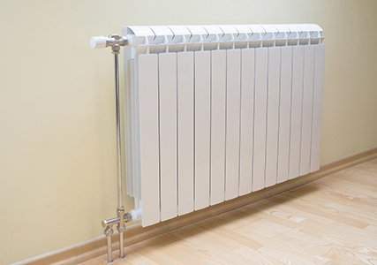 5 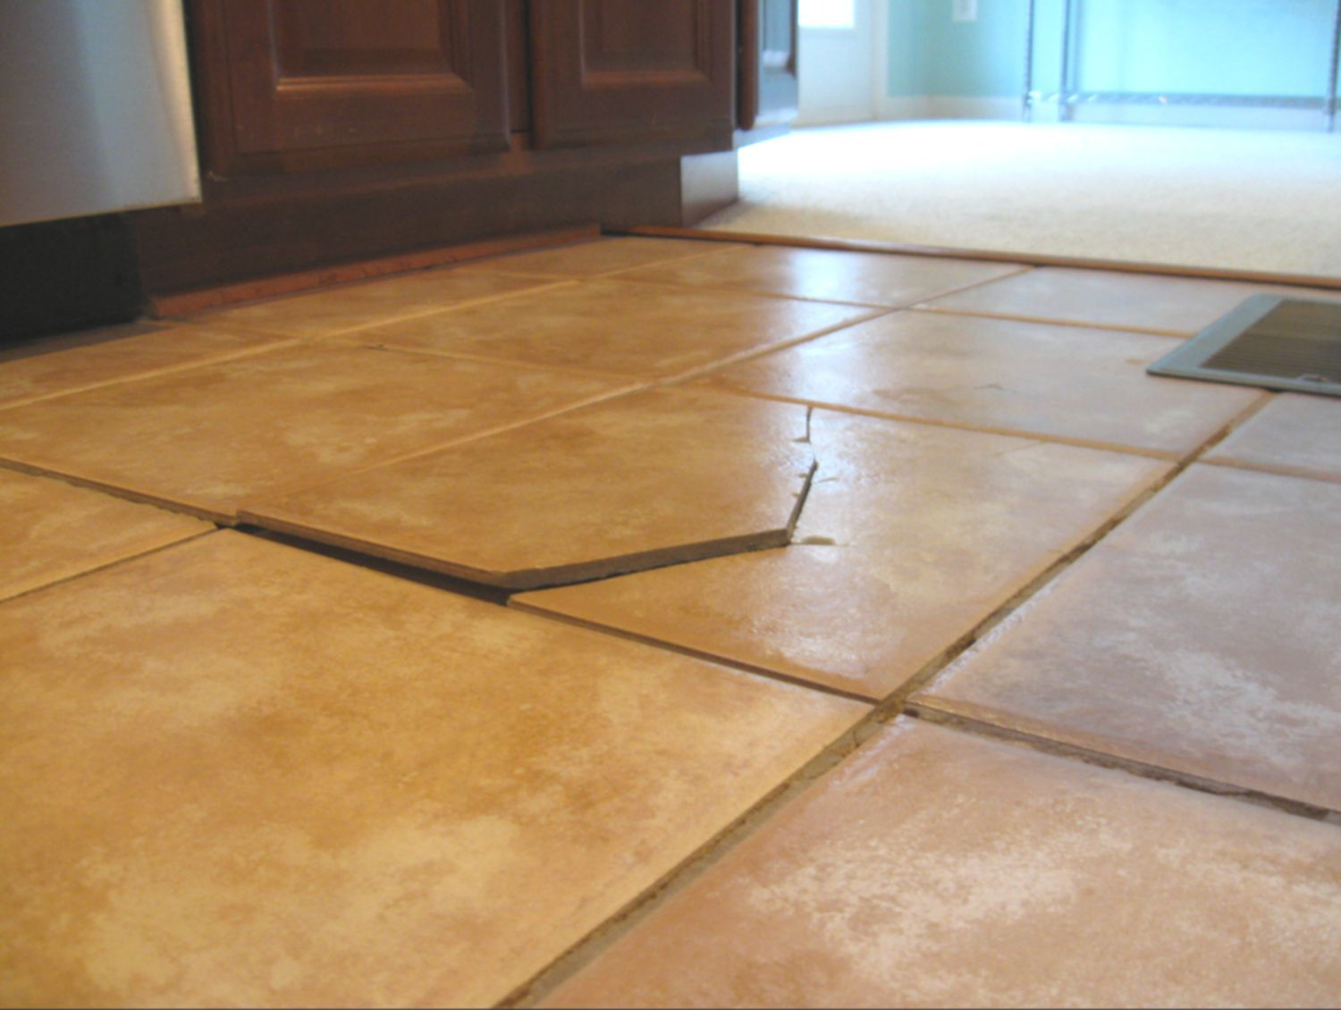

FIND THE AUDIO HERE: https://www.esl-lab.com/difficult/home-repairs/
1st listening:
Listen for the main ideas.
- What does Dave want? Dave wants a roommate.
- What does Randall think of the apartment? He thinks it was a mess. He’s shocked.
- Does Randall want to rent the room? Why or why not? No, because the house needs so many repairs!
2nd listening:
Listen for the specific problems. Check the problems the apartment has.
- Stained carpet (yes)
- Very old appliances (no) “latest/newest appliances”
- Broken refrigerator door (yes)
- Light is broken (no) “x”
- Shower tile needs replaced (yes)
- Window needs fixing (yes)
- Central heating doesn’t work (yes)
- Washing machine leaks (no) “x”
3rd listening:
Listen for the overall story. Choose the correct answer.
- Dave needs a roommate to pay for rent because:
  - He lost his job.
  - He’s working less hours to go back to school.
- What is wrong with the living room carpet?
  - It’s stained.
  - It’s torn/ripped.
  - It’s old.
- How did Dave fix the refrigerator door?
  - He pushed a box against it to keep it shut.
  - He called the repairman.
- What is wrong with the bathroom?
  - The windowpane is missing.
  - The tile needs replacing.
  - The sink is clogged.
- What does Randall decide at the end?
  - He will help Dave fix the house.
  - He will move in.
  - He will look for another place to live.

Homework: Complete the Dave’s Maintenance Request assignment.

