WELCOME TO DAY 8

Discussion (BR)
- Have you ever fixed something in your house? What happened? Are you a handyman?
- Have you ever painted (paint) your house? What color did you paint it?
No, I haven’t.
- Have you ever redecorated (redecorate) your house? When? What did you change in your house? Yes, I have.
- Have you ever unclogged (unclog) a sink or bathtub? How did you fix it? No, I haven’t.
- Has the alarm ever gone off (go off) in your house? Were you scared?

PRONUNCIATION
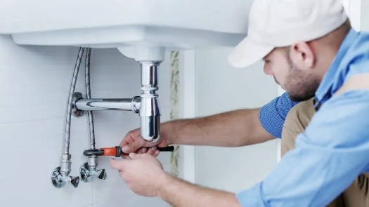
Intonation: How your voice goes up and down and change meaning.
For example, yes/no questions go UP
Information questions go DOWN
Syllable: one unit of sound
How many syllables?
Plu/mber (2) fix (1) dish/wa/sher (3)

Pro/per/ty (3) sho/wer (2)
Ligh/ting (2) leak (1)
Ba/tte/ries (3) a/larm (2)
Bro/ken (2) ma/na/ger(3)
Word stress
Word stress: the stressed syllable is l o n g e r, higher, and LOUDER than other syllables.

How do I know?

Some word stress rules:
plumber, shower, lighting (2 syllable nouns)
- - 90% of 2-syllable nouns have stress on the 1st syllable
prefer, describe, compare (2 syllable verbs)
- - 60% of 2-syllable verbs have stress on the 2nd syllable

MAINTENANCE FORMS

Your refrigerator door is broken. It doesn’t close. You need it fixed. | Some tiles in your bathroom are broken. You need a few tiles to be replaced. | The central heating doesn’t work. You need the repairman to come look at it and see what is wrong.

“I have a problem with my fridge door. Would you like to see and then fix it, please?”
“Please can you come to my apartment? Some tiles are broken. Can you send somebody to repair them?”
“Hello. Can you help me, please? My central heating doesn’t work. Can you send a repairman?”

- Interpret formal language.
- Practice filling out form.

