SAYING “NO” IN ENGLISH

The most common way to make a sentence negative in English is with the word NOT. However, this is not the only way to make a sentence negative. Today, we will learn about three other ways.

NEGATION with “NO”
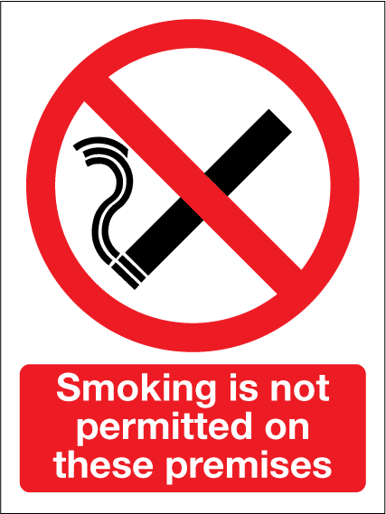
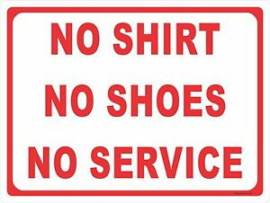
Have you ever seen signs like these ones? Think:
- What do they mean?
- Where do you see them?
- Do you notice a difference in the negatives?

ANSWERS:
- _
- _
- _

Maybe you notice that Sign #1 says “no”, but Sign #2 says “not”. Let’s see why.

(When you are finished, send this worksheet to shanson-lynn@zagmail.gonzaga.edu for feedback and corrections 😊)
In English, we use NOT and NO in different situations. Some patterns are:
We use NO | We use NOT
Answering a yes/no question  Did you work today? No. | For verbs, to show the opposite action  I do not like this job.  He is not working on Tuesdays.  We cannot take vacation right now.
For nouns without an article  Sara has no idea where her phone is.  This is no time for arguing.  The boss has no information. | For nouns with an article  He is not a teacher.  I liked my old coworker, not the new one.
Before gerunds  No smoking.  No texting at work.  No working overtime. | For adverbs that describe a verb  The office is not very cold.  Not surprisingly, the meeting was long.

PRACTICE:
- I can __________ come to the meeting at 6 p.m.
- The break room has __________ coffee.
- It’s __________ an impossible assignment.
- Kelly does __________ read slowly.

Sometimes, we can use both – but we say it differently.
COMPARE
He paid no attention to me. | He did not pay any attention to me.
I’ve decided that I have no choice. | I’ve decided I don’t have any choice.

(You see, with NOT we add ANY).

MORE PRACTICE with NO and NOT HERE:
https://www.perfect-english-grammar.com/no-and-not-exercise-1.html
https://www.perfect-english-grammar.com/no-and-not-exercise-2.html
SOME FUN IDIOMS with NO and NOT
No problem | It’s no good | No worries | It’s not up to me | It’s not worth it
(It’s okay) | (It won’t/doesn’t work) | (Don’t worry about it, it’s okay) | (It’s not my decision) | (The result is not worth the effort)

These are some common, everyday expressions in English. Try to fill in the blanks with them:
- I can’t come in to work on Friday because I have a dentist appointment, is that okay? - Yeah, ________________________.
- Why did you throw away the machine? – Because ________________________.
- I could go back to school, but I have a good job now. – Then don’t go, ________________________.
- I’m so sorry, I forgot to set my clock and I overslept! – Oh, ________________________.
- Can I take two weeks’ vacation in July? – Ask Barb, ________________________.
- I’m so nervous for my job interview. – ________________________, you’re very qualified for the job.

TELL ME ABOUT YOUR JOB
Describe your job. Where do you work? What are and aren’t your job responsibilities? What do and don’t you like about your job? Try to use NO, NOT, and the IDIOMS in your paragraph!
14.

