English for Medical Purposes - A Physical Examination
Doctor: When did you last come in for a physical exam?
Patient: Two years ago.
Doctor: Have you had any other exams recently? Blood work, X-rays, an EKG or an ultra-sound?
Patient: No.
Doctor: How have you been feeling in general?
Patient: Pretty well.
Doctor: Could you roll up your left sleeve? I'd like to take your blood pressure.
Patient: Certainly.
Doctor: 120 over 80. Good. Do you exercise regularly?
Patient: No. I need to get out more.
Doctor: That would be a good idea. How about your diet?
Patient: I eat mostly healthy food.
Doctor: Good! Now, I'm going to use my stethoscope to listen to your heart. Breathe in and hold your breath. Please breathe deeply... Everything sounds good. Let's take a look at your throat. Please open wide and say 'ah'.
Patient: 'ah'
Doctor: OK. Everything looks good. I'm going to order some blood work, so please take this slip to the front desk. They'll arrange an appointment for the tests.
Patient: Thank you!
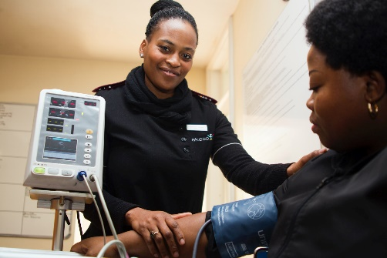
https://unsplash.com/photos/pA0uoltkwao

