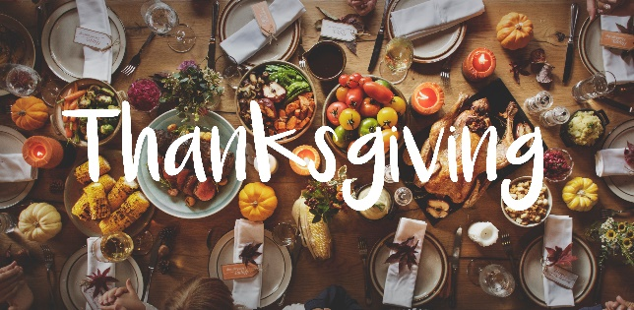
Name: _________________________

The History of Thanksgiving

Thanksgiving is an important holiday celebrated in the U.S. This listening activity will explore the history and development of the holiday from 1620-2021. There are four parts to the activity. When you are finished, email it to Sara (shanson-lynn@zagmail.gonzaga.edu) for feedback.

PART ONE
Start by writing what you already know about Thanksgiving.
What do you already know about Thanksgiving?
How is it celebrated?
Who celebrates it?
What day is it this year?
What is the history behind the holiday?

Think about what might be discussed in the video.
What might the video talk about?
What images might the video show?

PART TWO
Watch the video for the first time. Listen and look at the images. It is okay if you do not understand everything.
https://www.history.com/topics/thanksgiving/history-of-the-thanksgiving-holiday-video

After you watch the video, put the images in order.
1. _____ 2. _____ 3. _____ 4. _____ 5. _____ 6. _____
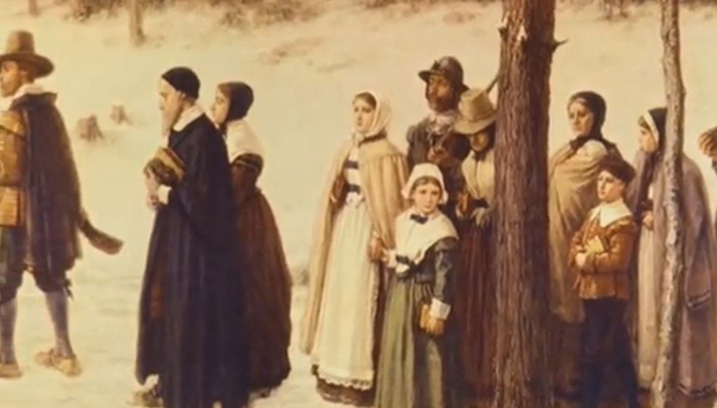
A. Puritans celebrated by praying B. Many Pilgrims died in the winter from hunger.
and thanking God.
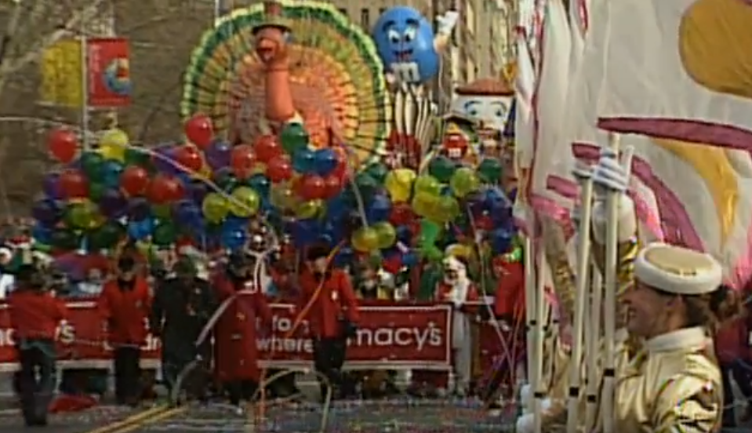
C. New traditions were added like watching D. The Pilgrims shared a feast with the Native
football, shopping, and going to parades. Americans.
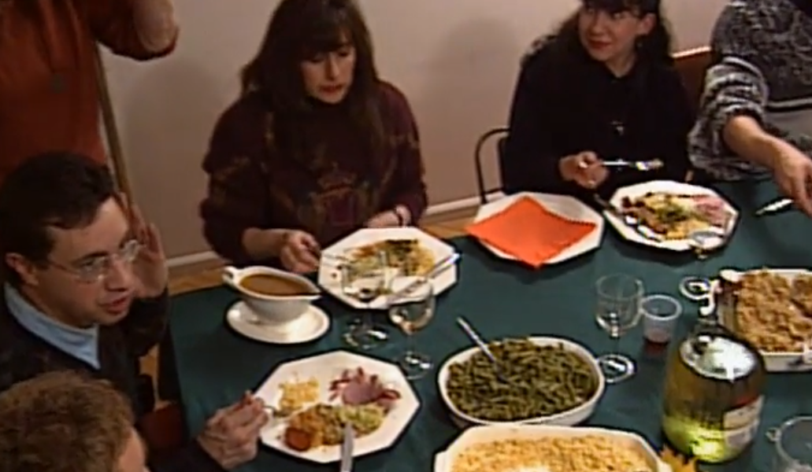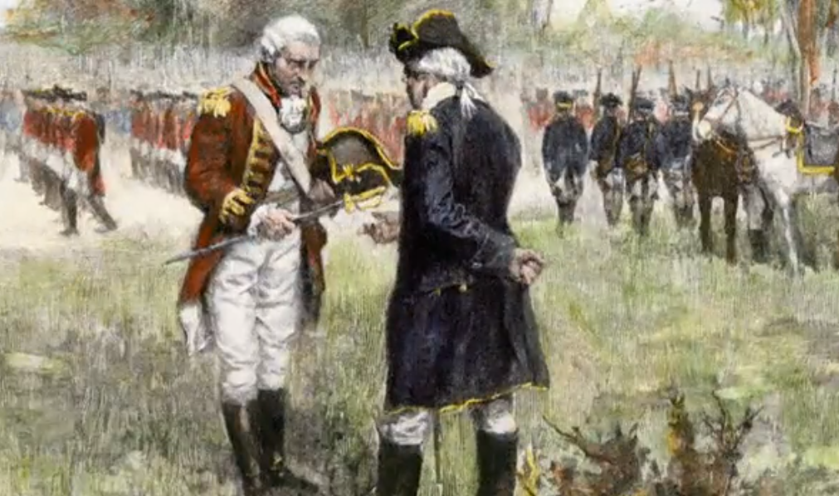
E. People celebrate by giving thanks and F. The colonies celebrated and gave thanks for
eating with family and friends. winning a battle against the British.

PART THREE
The video has many vocabulary words. Try to discover the definition from watching the video, looking up the definition, or asking a friend. Write your definitions below and add a picture.
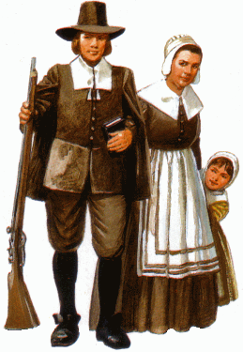
- the Pilgrims: _______________________________
- the Puritans: _______________________________
- a feast: _______________________________
- the colonies: _______________________________
- the harvest: _______________________________
- a battle: _______________________________

PART FOUR
Watch the video again. Follow the timeline and fill in the missing words. Listen again to check your answers.
first winter hunting thanks feast

November family football battles shopping

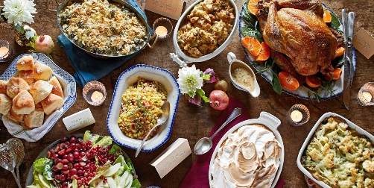

PART FIVE
Answer the questions with your thoughts and opinions.
- What is something new you learned in the video? _______________________________
- What was something you already knew? ______________________________________
- What was the most interesting thing you learned? ______________________________

