MONDAY, 7/20 – DAY 16 CLASS

VOCABULARY
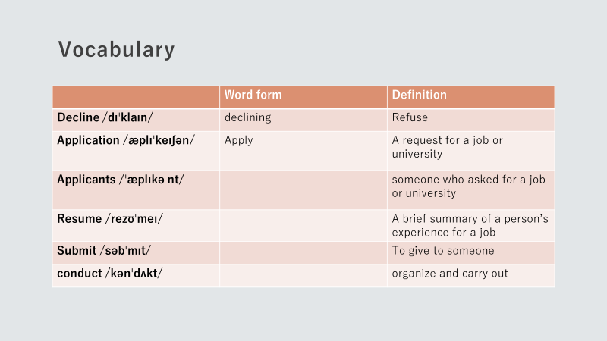

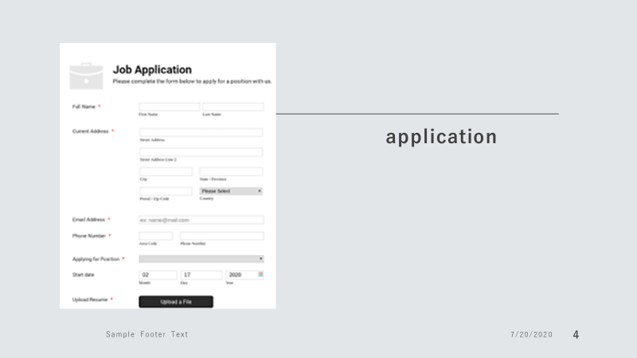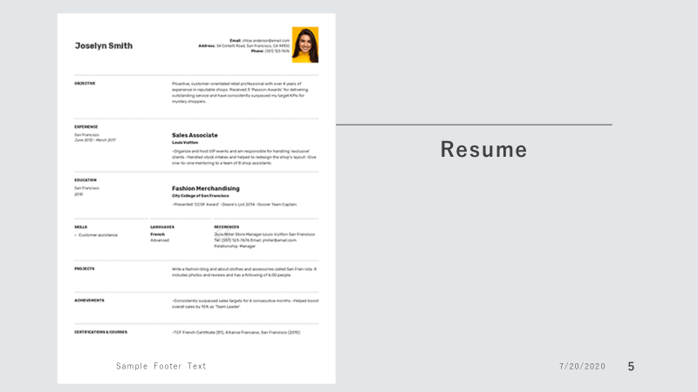

READING
Steps in the Job Searching/Hiring Process

Applying for a job can be a stressful process, so you want to do everything you can to increase your chances of success. Success starts with understanding the steps in the job searching process. If you understand the process of applying for a job, you will increase your chances of getting a job.

The simple process of searching for, and getting, a job has five steps: searching for a job, applying for a job, the job interview, getting hired/not getting hired, accepting or declining a job offer.

- Search for a job

The first step in finding a job is to search for a job. People can find jobs by searching online, on social media, in newspapers, by talking to friends, and visiting businesses.

- Apply for a job

Once you find a job that you want, you need to apply for it. You will need to complete a job application and possibly provide a resume and/or cover letter. After you complete the job application, you need to submit the job application to the employer. After you submit your job application, the employer will review your application.

- Job interview

If your application closely matches what the employer is looking for in a future employee, you will likely be invited to conduct a job interview.

- Hired/Not Hired

After the employer is done interviewing you and other applicants, the employer will make a decision on who to hire. You will either get hired or not hired.

IF YOU GET OFFERED A JOB…

- Accept/decline the job

If you have been offered a job, you need to decide if you want to accept or decline the job. You may want time to think about whether you want the job or not. You may have been offered another job at the same time. At that point, you need to decide which job you want to accept and which job you want to decline.

ONE LAST THING…

Not all job searches/hiring processes have these five steps. For some jobs, you may not have to provide a resume or cover letter in the job application. Some jobs do not require an interview. Also, you may not make it through all five steps. A lot of people do not even reach Step 3 (interview).
Page Break

CHECKING FOR UNDERSTANDING (True or False?)

1. | Searching for a job is the first step of the job search process. | True or False?
2. | People can find jobs by searching online, on social media, reading newspapers, by talking to friends, and visiting businesses. | True or False?
3. | When you apply for a job, you need to submit a job application and possibly provide a resume and/or cover letter. | True or False?
4. | If your application does not closely match with what the employer is looking for, you will still be likely to get an interview. | True or False?
5. | You have to provide a resume and/or cover letter with every job you apply for. | True or False?

