Hello, GECO!

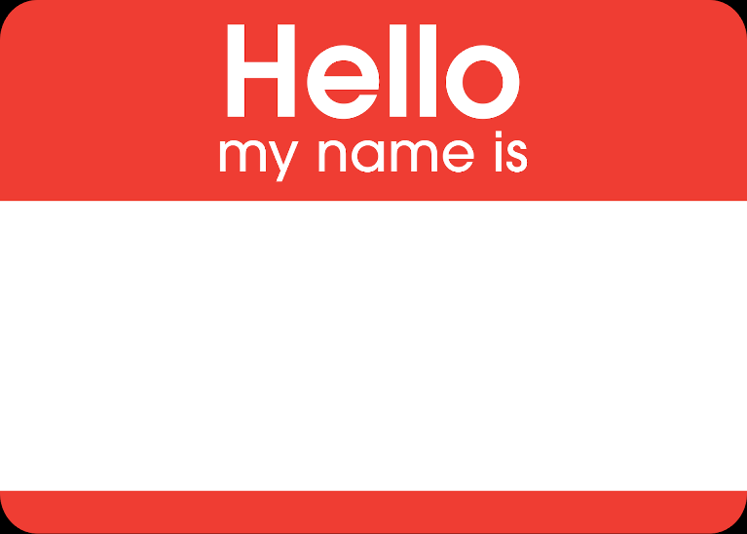
What is your name?

About GECO
- We talk about:
9/19 | Hello
9/26, 10/3 | One: School and kids
10/10, 10/17 | Two: Doctors
10/31, 11/7 | Three: Jobs
11/14, 11/21 | Four: Houses | 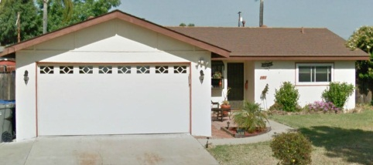
12/5 | Goodbye

- We have different teachers.

- You come to 5-10 classes = you get a certificate.
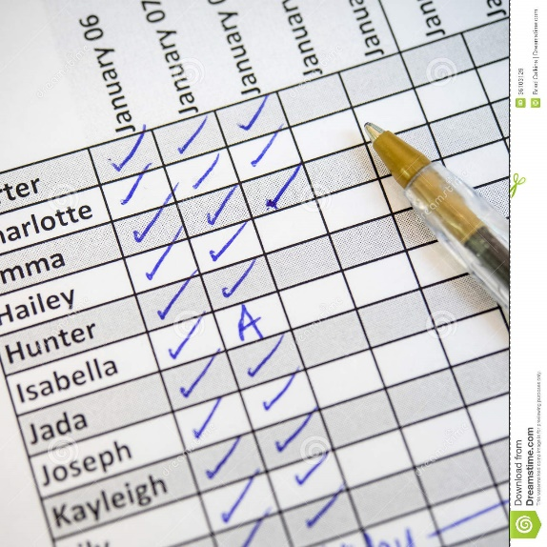 = 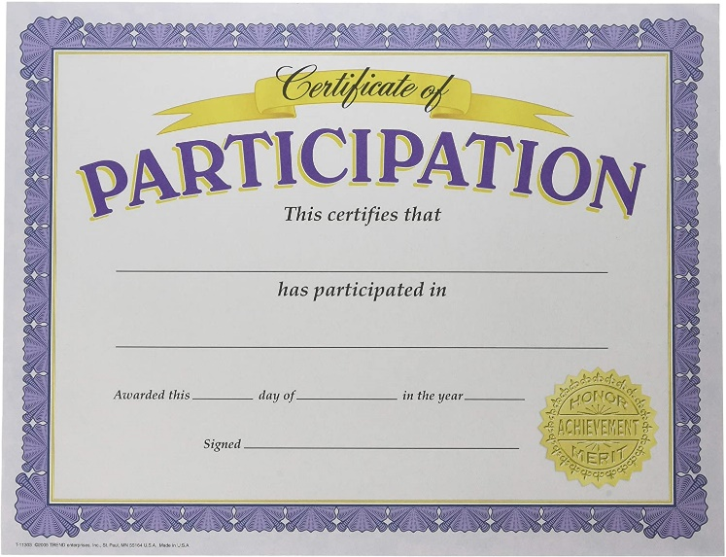
Take attendance.
- Write me your name and email in the chat.

Today, we get to know each other. We practice English. We practice the technology.
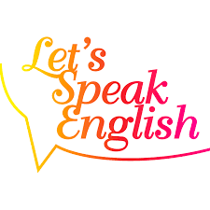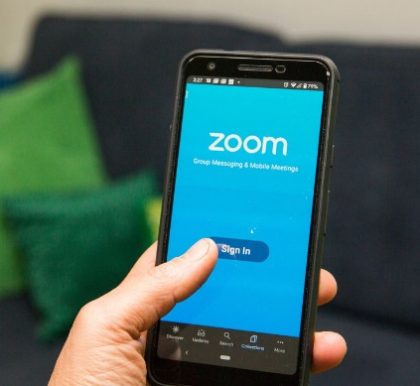

Questions?

Questions.
- What is your name?
- Where are you from?
- Where do you live?
- What languages do you speak?
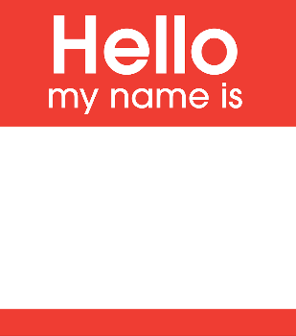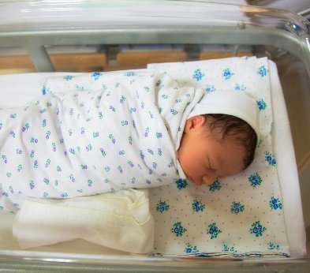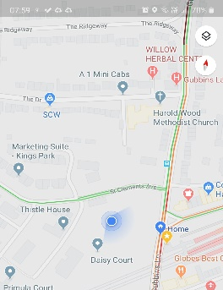
My name is ________________.
I am from _________________.
I live in ____________________.
I speak ________________ and ________________.

Family vocabulary.
Wife Husband Kids (two sons, one daughter) Family
Son Husband Wife Daughter
Wife Daughter Wife

?
I have… I don’t have…
I have two daughters.
I have a husband.
I have a wife.
I don´t have sons.
? I have…

Your family. (in breakout rooms, talk)
I have… I don’t have…
Now…
Mom Brother Sister Brother Dad Family
Brother Dad Mom Sister
Mom Sister Mom

?
I have… I don’t have…
I have a sister. I have a dad. I have a mom. I don´t have a brother.

Brother = for boys (male gender)
Sister = for girls (female gender)
Siblings = for everyone (no gender, unspecific)
? I have… I don’t have…
I have a sibling. I have a sister. I don’t have a brother. I have parents.
? I have…
I have a mom and a dad. I have three siblings.

Combine.
Husband, wife, son, daughter, family
Mom, dad, brother, sister, siblings

I have… I don’t have…

Exit ticket:
From student to teacher, what do you want me to know about you?

