Key Words Check

Directions: Teacher ask students to fill out the blank box

1. **Doctor:** Doctor patients at the hospital.
2. **Engineer:** Engineer roads and buildings.
3. **Teacher:** Teacher students at school.

1. **Policeman:** Policeman thieves.

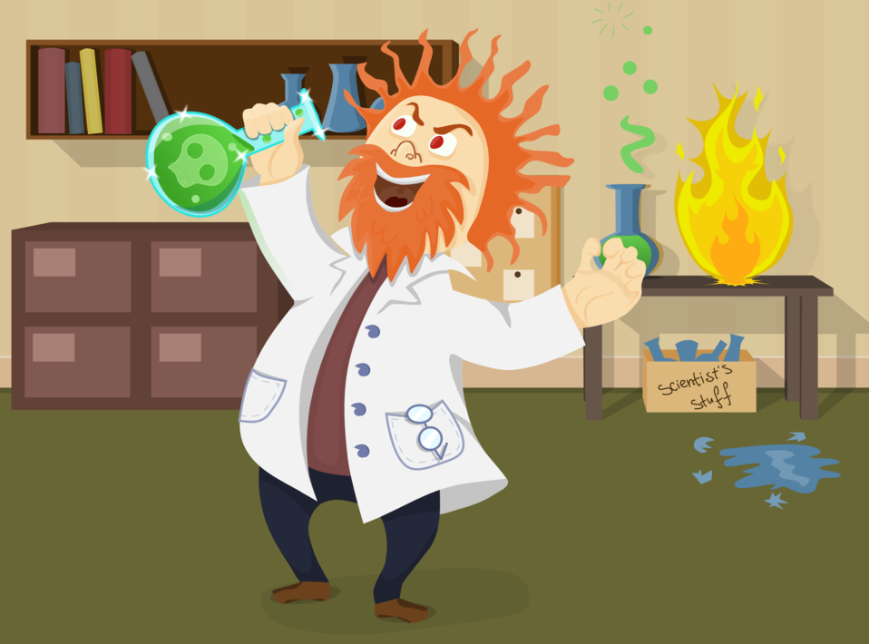

1. **Pilot:** Pilot an airplane.
2. **Scientist:** Scientist new things.
3. **Soldier**: Soldier the nation.
4. **Chef:** Chef food in hostels and restaurants.

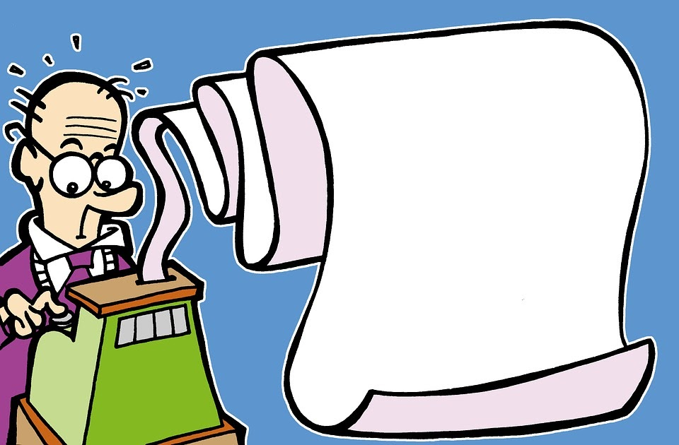

1. **Postman:** Postman mails.
2. **Bus driver:** Bus driver a bus.
3. **Cashier:** Cashier moneys.

<Key Verbs>

Catches, Operates, Protects, Delivers, Receives, Treats, Teaches, Invents, Drives, Builds Cooks,