Warming Up: Matching Game

Directions:

1. Find a sentence matching a picture and connect them by a line.
2. After create a sentence, read it aloud!
3. 

* ・**teaches student.**





* ・**operates an airplane.**

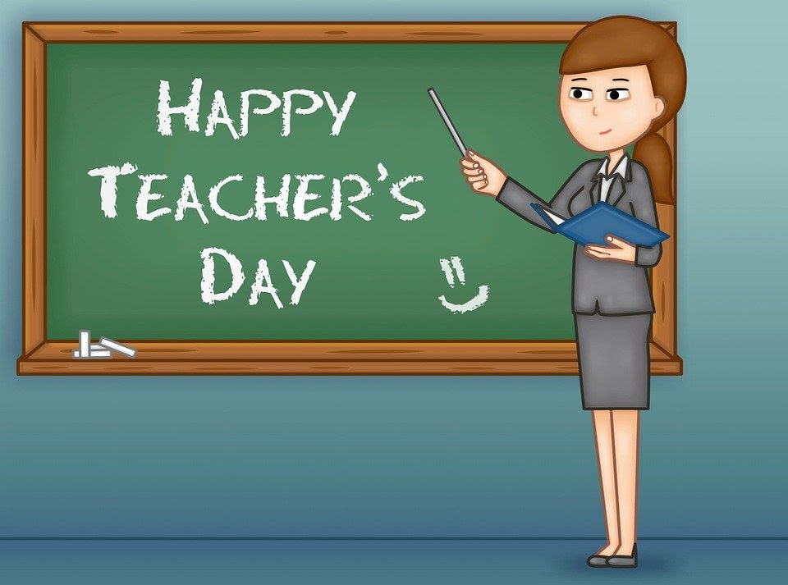



* ・**treats patients.**





* ・**builds roads and buildings.**



* ・**catches thieves.**

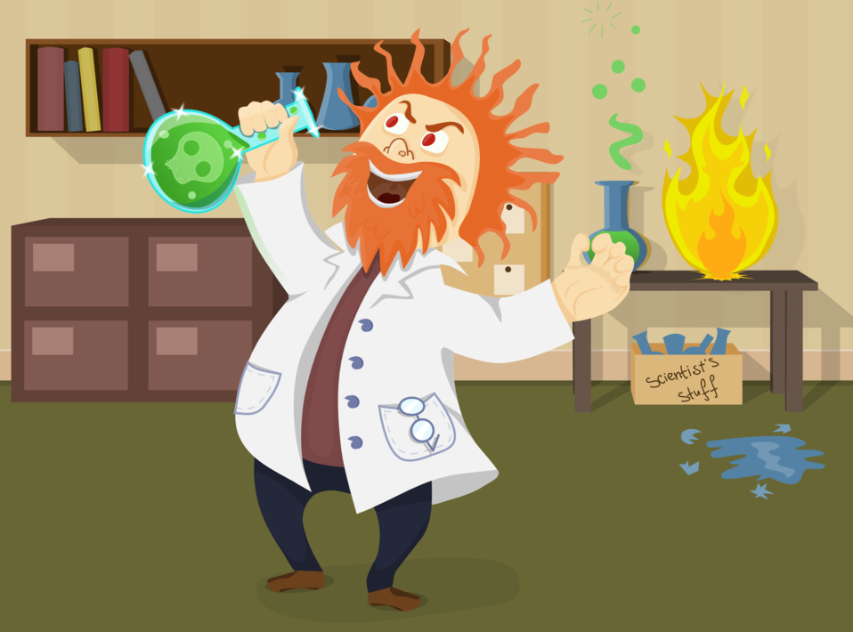

* ・**cooks food in hotels.**





* ・**delivers mails.**





* ・**drives a bus.**



・ ・**receives money**.



* ・**invents a new material.**