Housing & Maintenance Vocabulary Review

Words:

Landlord

Tennant

Handyman

Electrician

Plumber

Exterminator

Leaking

Clogged

Broken

Peeling

*Fill in the blank with the vocabulary word that best completes the sentence.*

1. When I have a general problem, I call the building ______________________ to come fix it.
2. The_____________________ is the person who owns the building.
3. The toilet is not flushing, it is ____________________.
4. There are cockroaches in my house, I should call the _______________________.
5. The paint is __________________, it is coming off of the wall.
6. The__________________ is the person who pays rent to live in the building.
7. The glass on the window shattered, it is ______________.
8. The electric wiring is not working in my house, so I called an ___________________.
9. There is water dripping from the sink, the sink is ____________________.
10. I was having a problem with my water pipes, so I had to get a _________________ to come look at the pipes.

What is the Problem?

*Describe the problem; then discuss what you would do to fix the problem.*

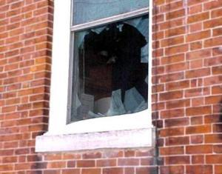

1. ___________________________



2.___________________________

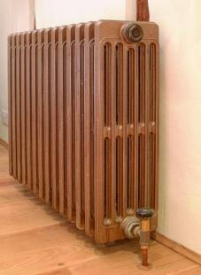

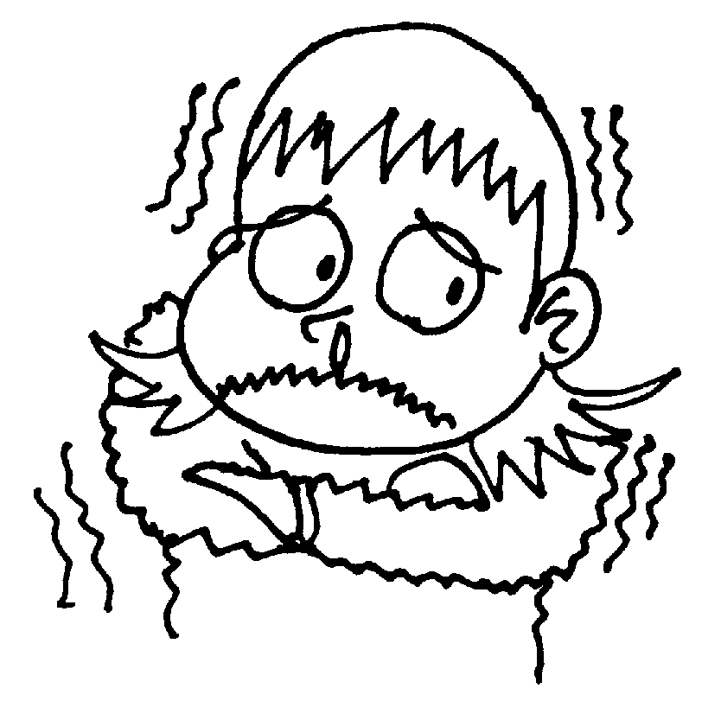

3.___________________________

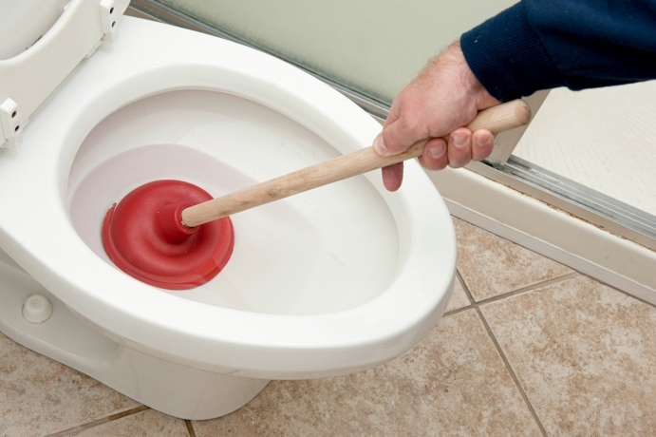

4.___________________________

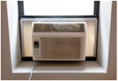

5.___________________________

6.___________________________

7.__________________________