What is this? What are these?

What is in my bag?
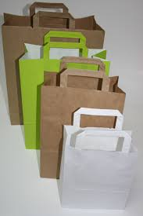
What is this? Question for singular nouns
Answers for Singular Nouns.

This is a _________ OR
This is an_________
Use this is to introduce or talk about one person or thing near you. Example. This is my friend, or this is an orange.

What are these? Question for Plural nouns

Answers for Plural Nouns.
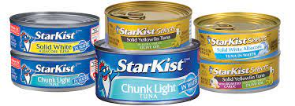

- These are __________

Use these are to introduce or talk about two or more people or things near you.

Exercise 1 This and These.

Circle the correct answer. Use this or these.
- This/ These are my Photos.
- This/ These is my mother.
- This/ These are my sisters.
- This/ These is my father.
- This/ These is my apartment.
- This/ These are my friends.

Exercise 1 Editing.

Find and correct five mistakes in the conversations.
- A: These is my friend Pedro.
B: Hi, Pedro.
- A: This are my brothers.
B: Hello, nice to meet you.
- A: This my partner, Juan.
B: Hi, Juan.
- A: is these your books?
B: No, they not.

References
Eckstut-Didier, S. (2012). Focus on Grammar 1. New York: Pearson.

