What’s the Word?
X-ray
ultrasound
examination
stethoscope
technician
bloodwork
doctor
nurse
symptom
EKG
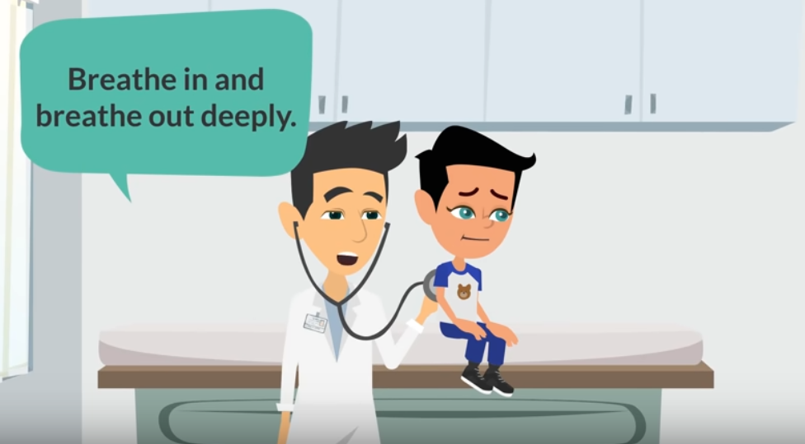
https://youtu.be/RLG8Nyve2vg

