What’s the Word?
X-ra_
ultras_un_
ex_min_tion
stet_oscop_
tec_nici_n
bl_odwo_k
d_ct_r
nurs_
sym_tom
E_G
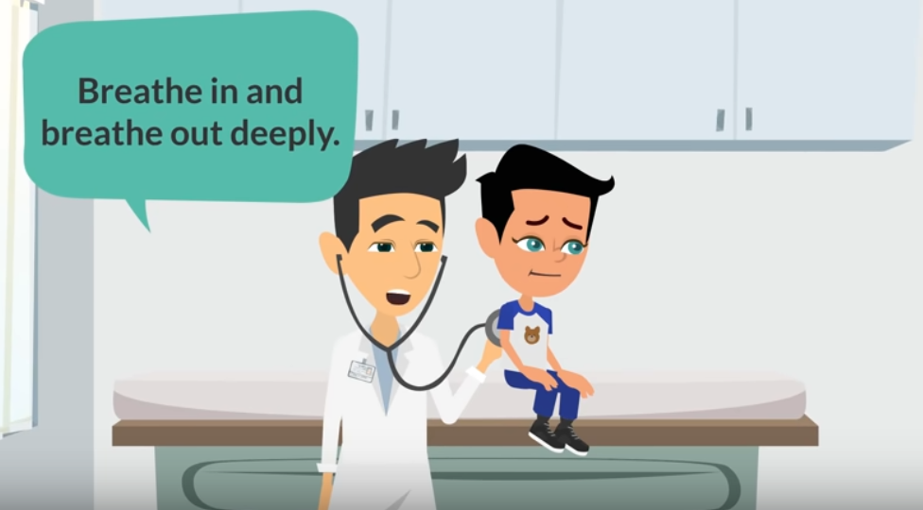
https://youtu.be/RLG8Nyve2vg

